Database assignments solution report
· Student id: 23110107
· Student name: Obada Alhalaybeh
· Section number: 5
Contents
Part 1 2
1. Introduction 2
2. Identify user and system requirements for designing a database based on the provided scenarios. 2
2.1User and System Requirement 2
2.2Data requirements 3
3 database design 4
3.1 conceptual design 4
3.2 Schema and Mapping 4
3.3 Logical Design 7
3.4 Physical Design 8
3.5 Effectiveness of the design 9
4 Normalization 13
4.3 3 NF (Third Normal Form) 15
5 physical schema 16
6 Database Development 16
6.1 Database Overview 16
6.2 Security 22
6.3 User Interface 24
6.3.1 Flowchart and Data Movement Diagrams 24
6.3.2 Interfaces Development 26
7. Maintenance 27
7.1 Database recovery & backups 27
7.2 Database maintenance in general 30
8 Testing 32
8.1 Data Validation 32
8.2 Output Validation 33
8.3 Security Validation 35
8.4 GUI Validation 37
8.5 Assess whether meaningful data has been extracted 40
8.6 Assess the effectiveness of testing 44
9 Evaluation of database solution 45
9.1 Effectiveness of the database solution based on user and system requirement 45
9.2 Suggested improvements 46
9.3 Evaluation based on improvements needed 47
10 User Documentation 48
10.1 System Overview 48
10.2 Using the system 48
10.3 Frequently asked questions 55
10.4 Contact information 55
Reference 56

Part 1

Introduction
This technical documentation provides a comprehensive overview of a relational database system designed for the EDU Youth Foundation. The system helps the foundation manage the donor data, monitor contributions, organize events, and streamline staff and donor communications. The database serves as a central repository, ensuring efficient data storge and retravel also ensuring data integrity through a propriate design practice.
The primary purpose of this documentation is to guide the development and understanding of the database system. It describes the conceptual and logical designs, user and system requirements, and the procedures used to normalize the database. This document also explains relationships, schema mapping, and the evaluation of the database design's effectiveness. This guide makes sure that both technical and non-technical users can understand the features and advantages of the system by offering concise and thorough insights into the database structure.

Identify user and system requirements for designing a database based on the provided scenarios.

2.1User and System Requirement
User requirements:
- Donors.
- View donation history.
- Participate in events.
- Staff.
- Mange donor records and events.
- Track donations made by donors.
- Pick locations for events.
- Communicate with the donors
- Admin.
- Mange the overall database operations.
- Collect reports on the events and participation.
System requirements:
- The system must:
  - Store details about donors and staff.
  - Track donations.
  - Ensure data integrity.
  - Be able to scale for future.

2.2Data requirements
  - Donor (donor_id, name, phone, address, type, email)
A donor can make multiple donations. Additionally, a donor can have multiple addresses and multiple phone numbers. Donors can participate in multiple events, and each donor communicates with one staff member.
  - Donations (donation_id, amount, donation_date)
Multiple donations can be made during one event, and each donation is associated with a donor. also, multiple donations can belong to the same donor.
  - Events (event_id, event_name, event_date, location)
An event can have multiple staff members assigned to manage it. Events can also involve participation by multiple donors, and multiple donations can be made during a single event.
  - Staff (staff_id, name, role, email, phone, salary, annual salary)
Events can be managed by multiple staff members, and one staff member can communicate with multiple donors.

3 database design

3.1 conceptual design
conceptual design is a high level representation of data structure in a database, and it shows entities that should exist on this database and the relationships between them. The goal is to ensure that all the user’s data requirements are met.
The components:
- Entities
- relationships
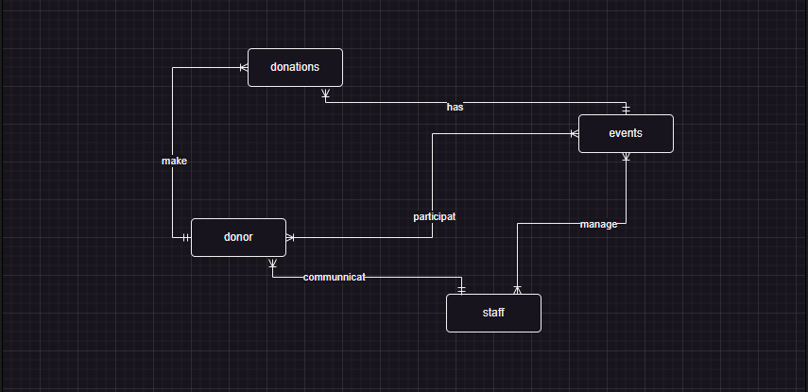
This diagram shows a donation system, the process start when the staff announce about event then the donor participates on it and make a donation for it, also the staff can communicate with donors.

3.2 Schema and Mapping
Donor (donor_id, name, phone, address, type, email)
Donations (donation_id, amount, donation_date)
Events (event_id, event_name, event_date, location)
Staff (staff_id, name, role, email, phone, salary, annual salary)
Note: the underline is the primary key.
Step2: Weak entities
There are no weak entities.
Step3: Removing derived attributes
Donor (donor_id, name, phone, address, type, email)
Donations (donation_id, amount, donation_date)
Events (event_id, event_name, event_date, location)
Staff (staff_id, name, role, email, phone, annual salary)
Note: I removed the salary since we can calculate it from the annual salary.
Step4: Multivalued attributes
Donor (donor_id, name, type, email)
Donations (donation_id, amount, donation_date)
Events (event_id, event_name, event_date)
Staff (staff_id, name, role, email, annual salary)
Donor_address (donor_id, address)
Staff_phone (staff_id, phone)
Donor_phone (donor_id, phone)
Event_location (event_id, location)
Note: I removed phone and location from donor and events and removed the phone from staff, also the address.
Step5: Composite attributes
Donor (donor_id, first_name, last_name, type, email)
Donations (donation_id, amount, donation_date)
Events (event_id, event_name, start_date, end_date)
Staff (staff_id, first_name, last_name, role, email, annual salary)
Donor_address (donor_id, state, city, street)
Staff_phone (staff_id, phone)
Donor_phone (donor_id, phone)
Event_location (event_id, location)
Note: I split name, address and event_date.
Step6: 1:1 relationship
There is no 1:1 relationship here.
Step7: 1:M relationship
Donor (donor_id, first_name, last_name, type, email, staff_id)
Donations (donation_id, amount, donation_date, donor_id, event_id)
Events (event_id, event_name, start_date, end_date,)
Staff (staff_id, first_name, last_name, role, email, annual salary)
Donor_address (donor_id, state, city, street)
Staff_phone (staff_id, phone)
Donor_phone (donor_id, phone)
Event_location (event_id, location)
Step7: M:N relationship
Donor (donor_id, first_name, last_name, type, email)
Donations (donation_id, amount, donation_date, donor_id)
Events (event_id, event_name, start_date, end_date)
Staff (staff_id, first_name, last_name, role, email, annual salary)
Donor_address (donor_id, state, city, street)
Staff_phone (staff_id, phone)
Donor_phone (donor_id, phone)
Event_location (event_id, location)
Donor_event (donor_id, event_id)
Staff_event (staff_id, event_id)
Final schema
Donor (donor_id, first_name, last_name, type, email, staff_id)
Donations (donation_id, amount, donation_date, donor_id, event_id)
Events (event_id, event_name, start_date, end_date)
Staff (staff_id, first_name, last_name, role, email, annual salary)
Donor_address (donor_id, state, city, street)
Staff_phone (staff_id, phone)
Donor_phone (donor_id, phone)
Event_location (event_id, location)
Donor_event (donor_id, event_id)
Staff_event (staff_id, event_id)
Note: under line is PK and red are FK, the pink entities are weak.

3.3 Logical Design
The logical design is more detailed version from the conceptual design that shows resolved relations (1:M N:M), attributes for the entities and primary and foreign keys. The goal is to get a well structured and normalized database schema that represents a blueprint for the physical design.
The components:
- It shows what the conceptual shows.
- Primary key
- Foreign key
- attributes
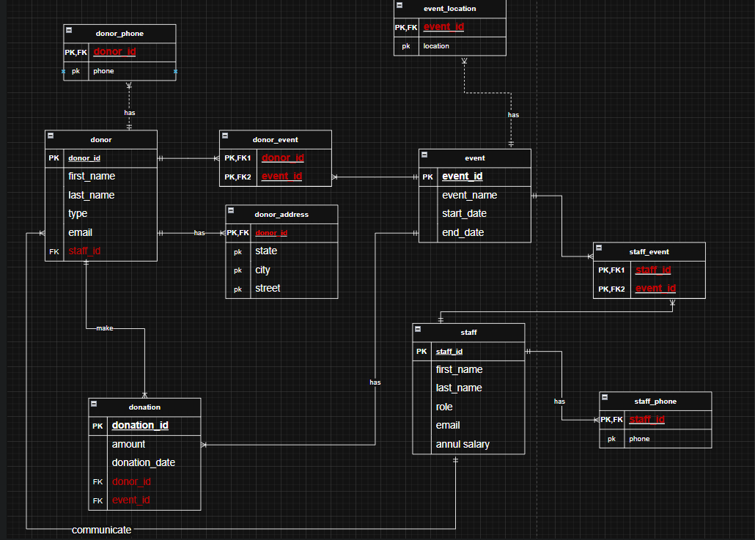
In this logical design it show new tables that are made form multi-value attributes and M:N relationships that make it easier to implement and more understandable.

3.4 Physical Design
The physical design represents the implementation of the logical data model in a relational database management system (RDBMS). It aim for optimizing the performance, defining data types for fields and defining constraints.
The components:
- all the things on the logical design
- data types
- constraints
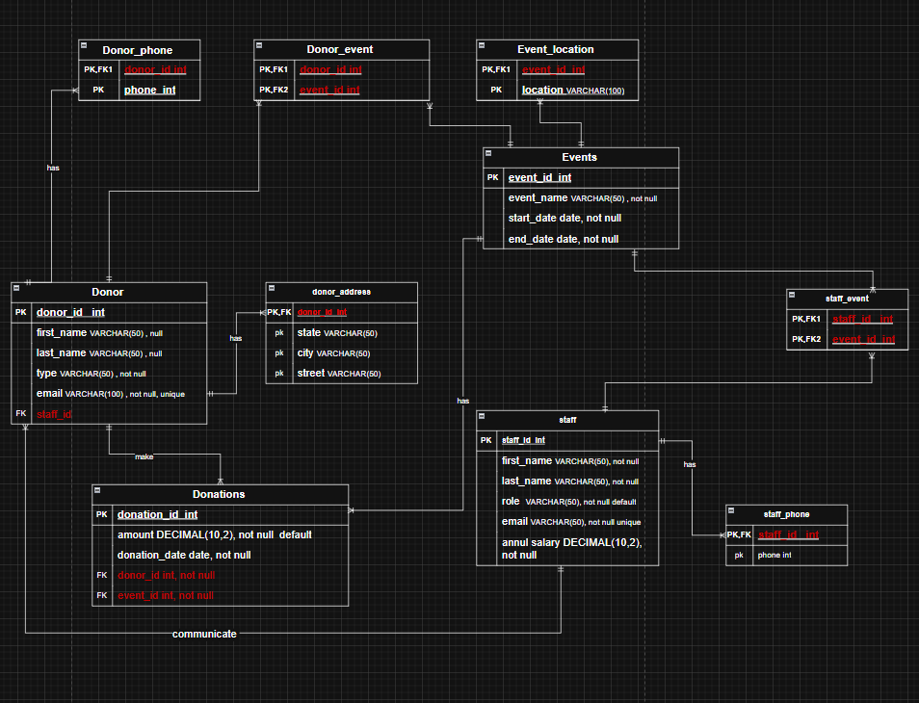
In this figure each row has a data type that will be used to insert the information like the first name has varchar so that mean the name will made of characters and so on to the int and there is a constraints for each row to like not null it does not allow the row to be not filled with the information.

3.5 Effectiveness of the design
The design process started with identifying specific entities that is essential to the system, like the donor, donations, events, staff. I chose this entities as they are core requirements for the EDU youth foundation.
Donor: its attributes (donor id, first name, last name, type, email) I chose this attributes so the donor can be recognized easily, and to get a level of security to not get scammed by frauds if I have that information.
- Donor id: this attribute should be unique for every donor since it’s a primary key and work as unique identifier the id is important and useful in a situation where the donor has the same name we can then Identify him buy the id and the id will be present on other entities as a forging key so we can relate to who did what.
- First name and last name: this attributes are present to help on the identification process and for easier communication.
- Type: this attribute provide insight on who is standing behind the donation as it is a single person or an organization.
- Email: its very important attribute as it allow the staff to communicate with the donor or send him news about events in general.
Donation: its attributes (donation_id, amount, donation_date) this entity is essential to track all the financial contributions made by the donors.
- Donation id: this attribute is a primary key that can uniquely identify each donation.
- Amount: this attribute will let the staff track the value of the donation and make more accurate financial reports.
- Donation date: this attribute record the date of the donation to keep the donation organized.
Events: its attributes (event_id, event_name, start_date, end_date) this entity is needed to be able to manage the events.
- event_id: this attribute is primary key so that each event can be identified.
- event name: the name attribute give us more clear way to identify the event
- start date and end date: this attributes indicate when the event begins and when it end giving a clear path to prepare for it.
Staff: its attributes(staff_id, first_name, last_name, role, email, annual salary)
- staff_id: this attribute act as a primary key so that each staff member has his own unique id even if his name is duplicated.
- First name and last name: this attribute help store the identification information about the staff.
- Role: this attribute specifies each staff member job.
- Email: this attribute store staff members emails to communicate between each other and with the donors.
- Annual salary: Tracks the salary details of the staff for payroll and budgeting purposes.
Donor Address: this entity was made to handle multi-valued attribute for the donor address, for example some donors may have more than one address, its attributes (donor_id, state, city, street)
- donor_id: here it’s a foreign key to link between the donor and the address.
- state: specifies the state where the address is located in.
- city: provide more detailed information.
- street: give deeper information about the address.
Donor Phone: this entity was made to handle multi-valued attribute for the donor phone, for example some donors may have more than one phone, its attributes (donor_id, phone)
- donor id: here it’s a foreign key to link between the donor and the phones.
- phone: this attribute store the actual phone number hence allowing for multiple rows for one donor.
Staff Phone: the staff phone entity is the same as the donor phone one
Event Location: this entity was made to handle multi-valued attribute for the location of the event as some events could have more than one location, its attributes (event_id, location)
- event_id: this is a foreign key to link the location with the event.
- location: holds the name of the location of the event.
donor event: this table resolve a (M:N) relation between donor and event a donor can participate in multiple events and the events can have multiple donors.
- Donor id: A foreign key linking to the Donor table.
- Event id: A foreign key linking to the Events table.
staff event: This table resolves a (M:N) relation between staff and events. Staff members can manage multiple events and each event may have multiple staff members assigned.
- Staff id: A foreign key linking to the Staff table.
- Event id: A foreign key linking to the Events table.
I made the conceptual design in purpose to provide a data centric perspective of the organization by showing how different entities relate to each other in other way it shows all the important requirements are captured before moving on the technical details.
The target audience of the conceptual design are:
- Database developers.
- Non-technical users on the business side.
The importance of the schema lies in the ability to translate the conceptual design into structured relational model and show how the data is stored in tables.
It also ensures that:
- All the relationships are correctly implemented
- Constrains like primary keys and foreign keys to enforce data integrity
Significance of the schema:
- Data organization: Define tables, attributes, and relationships. This ensures that the data is organized logically
- Referential integrity: by defining primary foreign keys The project prevents orphaned records and preserves relationships between tables
The information that were added to the logical design are:
- Attributes: its intended purpose is to define a specific property for the entity, it also help clarify further more to the primary key.
- Primary keys: it is a unique identifier for each table that make sure every row can be identifiable too.
- Foreign keys: Added to link related tables and enforce referential integrity.
The information that were added to the physical design are:
- Constraints: it helps to enforce rules at the database level that prevents the entry of invalid information.
- Data types: appropriate data types help optimize storge and the retrieval of information.
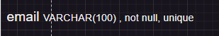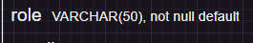
Normalization is important because it help reduce the redundancy as it prevents duplicate data in the tables, it also improves data integrity since it ensures consistency of the data by storing it in one place, and it ensure that it contain data related directly to the primary key.

- 1FN (first normal form)
multi valued attributes were removed from donor table, staff, and event 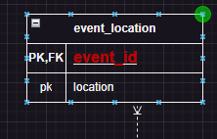 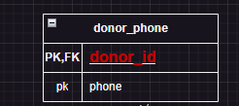 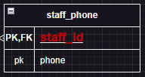
- 2NF (Second Normal Form)
partial dependencies were delt with. For example: In the Donations table, attributes like amount and donation_date depend only on the primary key (donation_id). No attribute depends solely on donor_id.
- 3NF (Third Normal Form)
Transitive dependencies were removed. For example: Staff salary details were stored in the Staff table instead of an Events table, ensuring that staff-related information is not repeated across events.
In conclusion the database creation process ensures a well-structured system. It can be scaled and effective for the EDU Youth Foundation. As a concept, the design incorporates the necessary requirements and relationships. As the plan translates these into relational patterns with logical organization and richness of context, it uses primary keys, foreign keys, and constraints in the logical and physical structure. To maintain consistency and increase work efficiency Standardization eliminates redundancy. Guaranteed data integrity and efficient storage space by responding to key needs such as donor management Event tracking and coordination of employees This design provides a robust, future-ready system that efficiently addresses user and system needs.

4 Normalization

4.1 1NF (first normal form)
Relations | Attributes | Violation description | Solution – Relations
Donor (first_name, last_name, type, email) | ---- | There is no primary key in the table, we can’t identify unique records in the table | Donor (donor_id, first_name, last_name, type, email) (add one)
Donor (donor_id, name, type, email) | name | Name is a composite attribute | Donor (donor_id, first_name, last_name, type, email)
Staff (staff_id first_name, last_name, role, email, phone, annual salary) | phone | Phone is a multi-value attribute | Staff (staff_id, first_name, last_name, role, email, annual salary)  Staff_phone (staff_id, phone)

4.2 2 NF (Second Normal Form)

Relations | Attributes | Violation description | Solution – Relations
Donor (donor_id, first_name, last_name, type, email, donation_id, amount, donation_date) | donor_id (first_name, last_name, type, email)  donation_id (amount, donation_date) | The non-prime attributes (first_name, last_name, type, email) depend on a part of the PK (donor_id)  And the non-prime attributes (amount, donation_date) depend on the other part of the PK (donation_id)  And this create partial dependencies | Donor (donor_id, first_name, last_name, type, email)  Donations (donation_id, amount, donation_date)
Events (event_id, event_name, start_date, end_date, staff_id, first_name, last_name, role, email, annual salary) | event_id (event_name, start_date, end_date)  staff_id (first_name, last_name, role, email, annual salary) | The non-prime attributes (event_name, start_date, end_date) depend on a part of the PK (event_id)  And the non-prime attributes (first_name, last_name, role, email, annual salary) depend on the other part of the PK (staff_id)  And this create partial dependencies | Events (event_id, event_name, start_date, end_date)  Staff (staff_id, first_name, last_name, role, email, annual salary)  Staff_event (staff_id, event_id)

4.3 3 NF (Third Normal Form)
Relations | Attributes | Violation description | Solution – Relations
Donations (donation_id, amount, donation_date, donor_id, first_name, last_name, type, email,) | Donation_id donor_id  donor_id (first_name, last_name, type, email)  Donation_id (amount, donation_date) | The PK (donation id) can determine any attribute in the table including donor_id. At the same time, the donor_id (first_name, last_name, type, email). As donor_id is not a candidate here, we have a transitive dependency. | Donor (donor_id, first_name, last_name, type, email)  Donations (donation_id, amount, donation_date)
Events (event_id, event_name, start_date, end_date, staff_id, first_name, last_name, role, email, annual salary) | event_id staff_id  event_id (event_name, start_date, end_date)  staff_id (first_name, last_name, role, email, annual salary) | The PK (event_id) can determine any attribute in the table including staff_id. At the same time, the staff_id (first_name, last_name, role, email, annual salary). As staff_id is not a candidate here, we have a transitive dependency. | Events (event_id, event_name, start_date, end_date)  Staff (staff_id, first_name, last_name, role, email, annual salary)  Staff_event (staff_id, event_id)

5 physical schema
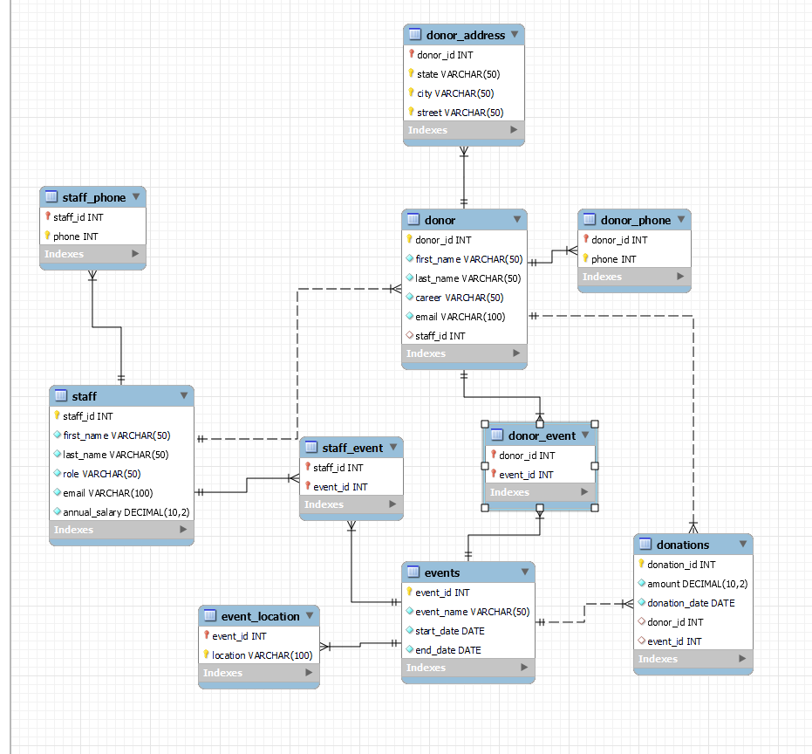

6 Database Development

6.1 Database Overview
Table | Name | Description
1 | Donor | The purpose of this table is to store information about individuals or organization making donations.  The attributes with type and constraints are:  donor_id: int, PK, auto increment. It’s a unique identifier for each donor  first_name: varchar (50), null. It’s first name for individuals  last_name: varchar (50), null. It’s last name for individuals  type: varchar (50), not null. It indicate whether the donor is individual or an organization  email: varchar (100), unique, not null. It is an email for communication  staff_id: int, FK. Links staff table.  relations:  Donor Staff one to many: Many donors can be managed by a single staff member, but each donor is assigned to only one staff member.  Donor Donations one to many: One donor can make multiple donations, but each donation is associated with only one donor.  Donor Donor Address one to many: one donor can have multiple address, but each address in associated with only one donor.  Donor Donor Phone one to many: One donor can have multiple phone numbers, but each phone number is associated with only one donor.  Donor Donor Event one to many(junction table for the many to many relation): multiple donors can participate in multiple events, multiple events can be participated in by multiple donors.
2 | Donations | The purpose of this table is to track financial contributions made by donors.  The attributes with type and constraints are:  donation_id: int, PK, auto increment. It’s a unique identifier for each donation  amount: decimal(10,2), not null. It is to monitor the value of the donation  donation_date: date, not null. It is to save the date the donation happen  donor_id: int FK. Links donor table.  event_id: int FK. Links event table.  relations:  Donations → Donor one to many: Each donation is associated with one donor, but a donor can make multiple donations.  Donations → Events one to many: Each donation can be associated with one event, but an event can have multiple donations.
3 | Events | The purpose of this table is to manage the information about the foundation events.  The attributes with type and constraints are:  event_id: int, PK, auto increment. It’s a unique identifier for each event  event_name: varchar (50), not null. Its for the name of the event  start_date: date, not null. Its for the start date of the event  end_date: date, not null. Its for the end date of the event  relations:  Events → Donations one to many: An event can have multiple donations, but each donation is associated with only one event.  Events → Event Location one to many: An event can have multiple locations, but each location is associated with only one event.  Events → Donor Event one to many(junction table for the many to many relation): An event can have multiple donors, and donors can participate in multiple events.  Events → Staff Event one to many(junction table for the many to many relation): An event can involve multiple staff members, and staff members can participate in multiple events.
4 | Staff | The purpose of this table is to store information about the employees that manage communication and events.  The attributes with type and constraints are:  staff_id: int, PK, auto increment. It’s a unique identifier for each staff  first_name: varchar (50), not null. It’s first name for staff members  last_name: varchar (50), not null. It’s last name for staff members  role: varchar(50), default ‘employee’, it is for sorting the positions of the staff  email: varchar (100), unique, not null. It is an email for communication  annual_salary: decimal(10,2), not null. It is for the annual salary for the staff  relations:  Staff → Donor one to many: One staff member can manage multiple donors, but each donor is assigned to one staff member.  Staff → Staff Phone one to many: One staff member can have multiple phone numbers, but each phone number is associated with only one staff member.  Staff → Staff Event one to many(junction table for the many to many relation): A staff member can manage multiple events, and each event can involve multiple staff members.
5 | Donor_address | The purpose of this table is to store physical address one donor could have more than one address.  The attributes with type and constraints are:  donor_id: int, PK, FK. Link the donor table  state: varchar(50), PK. State address  city: varchar(50), PK. city address  street: varchar(50), PK. street address  relations:  Donor Address Donor one to many: one donor can have multiple address, but each address in associated with only one donor.
6 | Staff_phone | The purpose of this table is to record the staff phone numbers a staff member could have more than one phone.  The attributes with type and constraints are:  Staff_id: int, PK, FK. Links staff table  Phone: varchar (15), PK. Phone numbers of the staff  relations:  Staff Phone → Staff one to many: One staff member can have multiple phone numbers, but each phone number is associated with only one staff member.
7 | Donor_phone | The purpose of this table is to record the donor phone numbers a donor can have more than one phone number.  The attributes with type and constraints are:  donor_id: int, PK, FK. Links donor table  Phone: varchar (15), PK. Phone numbers of the donor  relations:  Donor Phone Donor one to many: One donor can have multiple phone numbers, but each phone number is associated with only one donor.
8 | Event_location | The purpose of this table is to store the locations where the event will be held.  The attributes with type and constraints are:  Event_id: int, PK, FK. Links event table  Location: varchar (100), PK. It is for the location of the event  relations:  Event Location → Events one to many: An event can have multiple locations, but each location is associated with only one event.
9 | Donor_event | The purpose of this table is to track the donor participation in the events.  The attributes with type and constraints are:  Donor_id: int, PK, FK. Links donor table  Event_id: int, PK, FK. Links events table  relations:  Donor Event Donor one to many(junction table for the many to many relation): multiple donors can participate in multiple events, multiple events can be participated in by multiple donors.  Donor Event → Events one to many(junction table for the many to many relation): An event can have multiple donors, and donors can participate in multiple events.
10 | Staff_event | The purpose of this table is to track the staff members managing the events.  The attributes with type and constraints are:  staff_id: int, PK, FK. Links staff table  Event_id: int, PK, FK. Links events table  relations:  Staff Event → Staff one to many(junction table for the many to many relation): A staff member can manage multiple events, and each event can involve multiple staff members.  Staff Event → Events one to many(junction table for the many to many relation): An event can involve multiple staff members, and staff members can participate in multiple events.

Views table
view |  | Name | Description
1 | Donor Contribution |  | This view summarizes donor information and their contribution data.  It combines information about the donor, including name, type, email, and staff affiliation, with aggregated data about the number of donations they have made and the overall amount they have made.  Implementation:  The view uses a left join between the donor and donations tables to ensure that all donors are included, even if they have not made any donations. It calculates the total donations made by each donor using sum(da.amount) and counts the number of donations recorded for each donor using count(da.donation_id). The data is grouped by d.donor_id to ensure unique results for each donor.
2 | Event Donations |  | This view provides an overview of donations associated with events, including event details (name, start date, end date, and location) and the total amount of donations received for each event.  Implementation:  The view joins the events table with the event_location table to retrieve the location for each event and with the donations table to calculate the total donations linked to each event. The total donation amount is aggregated using sum(da.amount), and the data is grouped by e.event_id to ensure unique results for each event. This design ensures comprehensive information about events and their corresponding donation totals.
3 | Donor Contact Information |  | Donor contact information, such as complete name, email, address, and phone number, is combined in this view.  Implementation:  The view joins the donor table with the donor_address and donor_phone tables to include address and phone details for each donor. It uses concat(d.first_name, ' ', d.last_name) to combine the first and last names into a single full_name field for better readability. The LEFT JOIN ensures that all donors are included in the view, even if they do not have address or phone details available.
4 | Staff Contribution Report |  | This view summarizes staff members’ contributions by showing how many donors they manage and the total donation amounts attributed to those donors.  Implementation:  The view joins the staff table with the donor table to identify donors managed by each staff member and further joins with the donations table to calculate the total donation amounts linked to those donors. The number of unique donors managed by each staff member is calculated using count(distinct d.donor_id), ensuring each donor is only counted once. The total donation amounts are aggregated using sum(da.amount), and the data is grouped by s.staff_id to provide a clear summary for each staff member.

Procedures table
Procedure | Name | Description
1 | AddDonor | This procedure will insert a new donor into the donor table. The procedure will accept parameters like first_name, last_name, type, email, and staff_id.  Aim: Adds a new donor to the database.  Explanation: The AddDonor procedure accepts parameters for donor's first name, last name, type (Individual/Organization), email, and associated staff ID. It inserts these values into the donor table.
2 | UpdateDonorEmail | This procedure updates a donor's email based on the donor’s ID.  Aim: Updates the email of a specific donor  Explanation: The UpdateDonorEmail procedure takes donor_id and new_email as inputs, and updates the donor's email in the donor table.
3 | AddDonation | This procedure inserts a new donation into the donations table.  Aim: Adds a new donation record to the database.  Explanation: The AddDonation procedure accepts donation amount, date, donor ID, and event ID as inputs, and inserts them into the donations table.
4 | AssignStaffToEvent | This procedure assigns a staff member to a specific event.  Aim: Assigns a staff member to an event.  Explanation: The procedure takes staff_id and event_id as input and inserts them into the staff_event table to assign the staff member to the event.

6.2 Security
User name | Privilege Command | Description | Screenshot
admin | GRANT ALL PRIVILEGES ON edu.* TO admin; | The admin user has been granted all privileges on the edu database. This enables the user to perform all operations, including SELECT, INSERT, UPDATE, DELETE, CREATE, DROP, on any table within the edu database. | 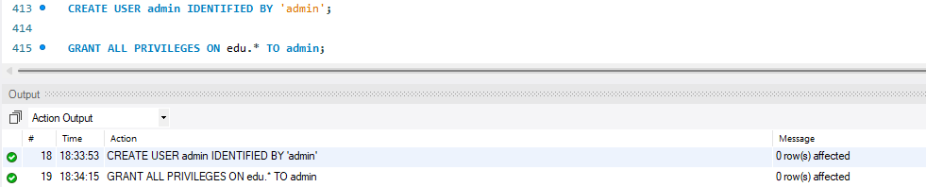
staff | GRANT SELECT, UPDATE ON edu.donor TO staff;  GRANT SELECT, UPDATE ON edu.donations TO staff;  GRANT SELECT, UPDATE ON edu.donor_address TO staff;  GRANT SELECT, UPDATE ON edu.donor_phone TO staff; | The staff user has SELECT and UPDATE privileges on the donor, donations, donor_address, and donor_phone tables in the edu database. This allows the staff user to view and modify the existing records in these tables. | 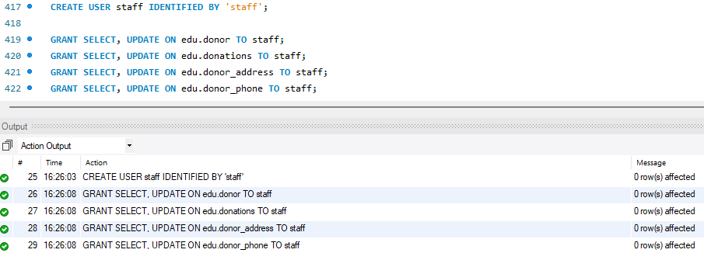
donor | GRANT SELECT ON edu.donations TO donor;  GRANT SELECT ON edu.donor_phone TO donor;  GRANT SELECT ON edu.donor_address TO donor; | The donor user has SELECT privileges on the donations, donor_phone, and donor_address tables in the edu database. This enables the user to view the records in these tables without modifying them. | 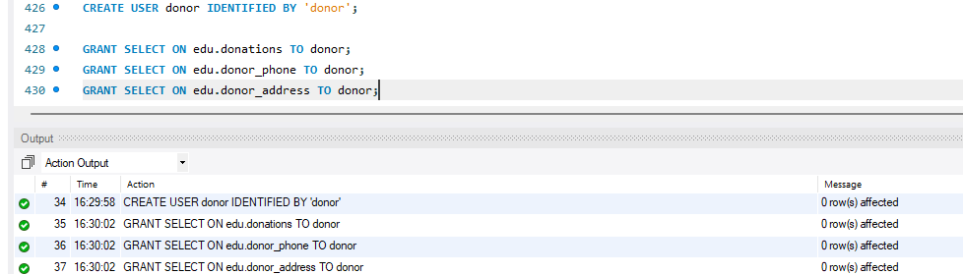

6.3 User Interface

6.3.1 Flowchart and Data Movement Diagrams
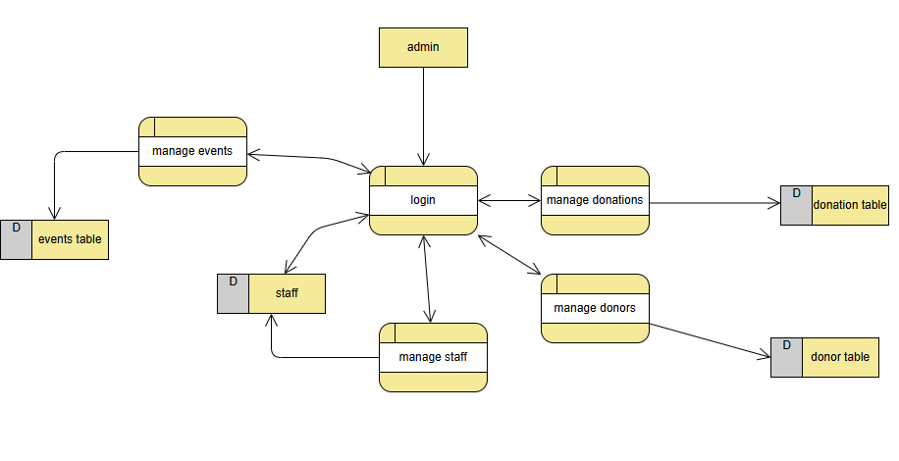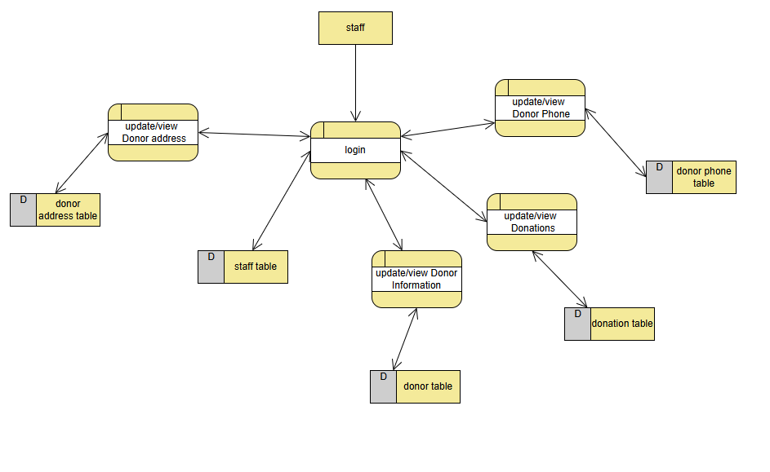
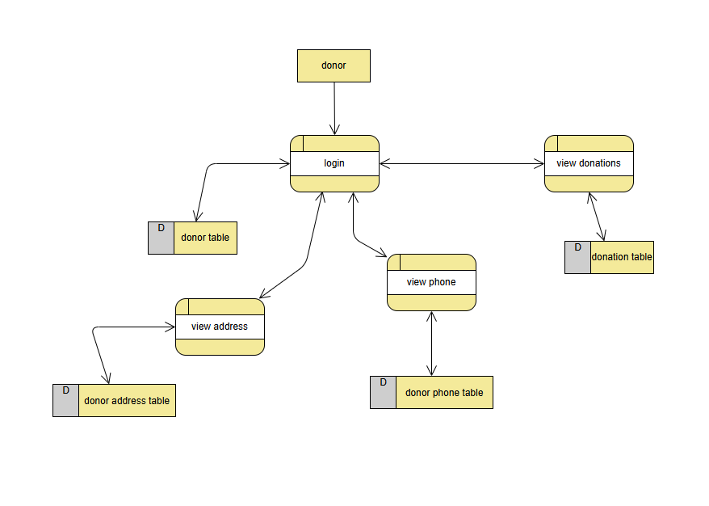
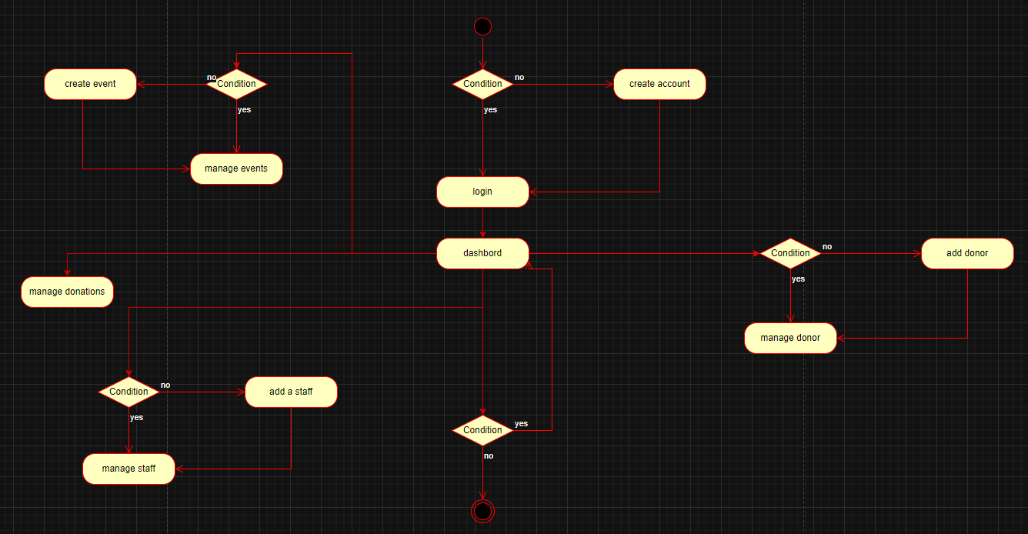

6.3.2 Interfaces Development
Page id | Title | Description | Screenshot
1 | Home page | This page allow you to connect to the database you want with the user you want, with the host and the port number too. | 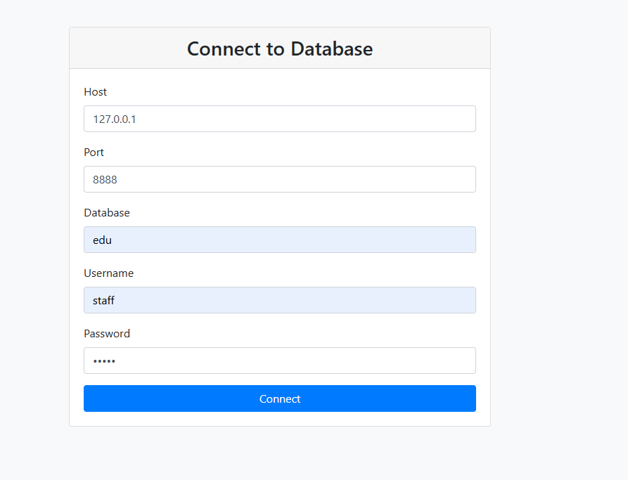
2 | Select table | This page show the loged in user the tables that he is authorized to see. | 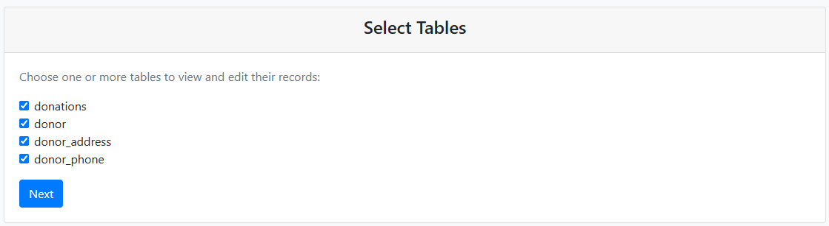
3 | Tables | This page show all the slescted tables form the previous page and display the contant of the tables. | 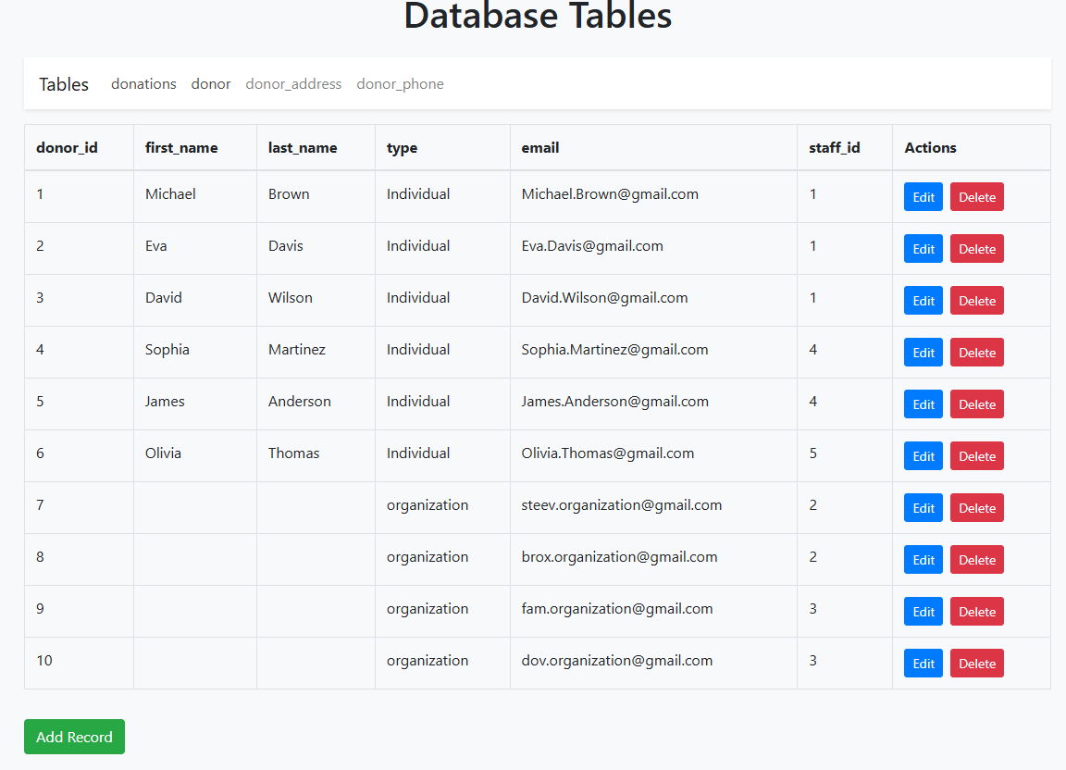
4 | Edite a row | This allow the user to edit a row from the selected table | 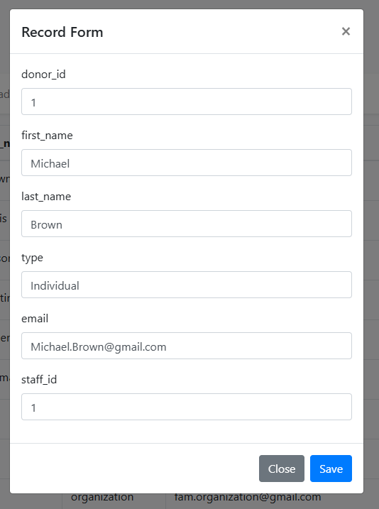

7. Maintenance

7.1 Database recovery & backups
database recovery and backup is important, as they ensure the data integrity and availability if something unexpected happens to the main database, since it prevents data loss, and maintain a good customer experience if some customer recode got lost the backup can help returning it.
Here is how to import and export the database:

Export:
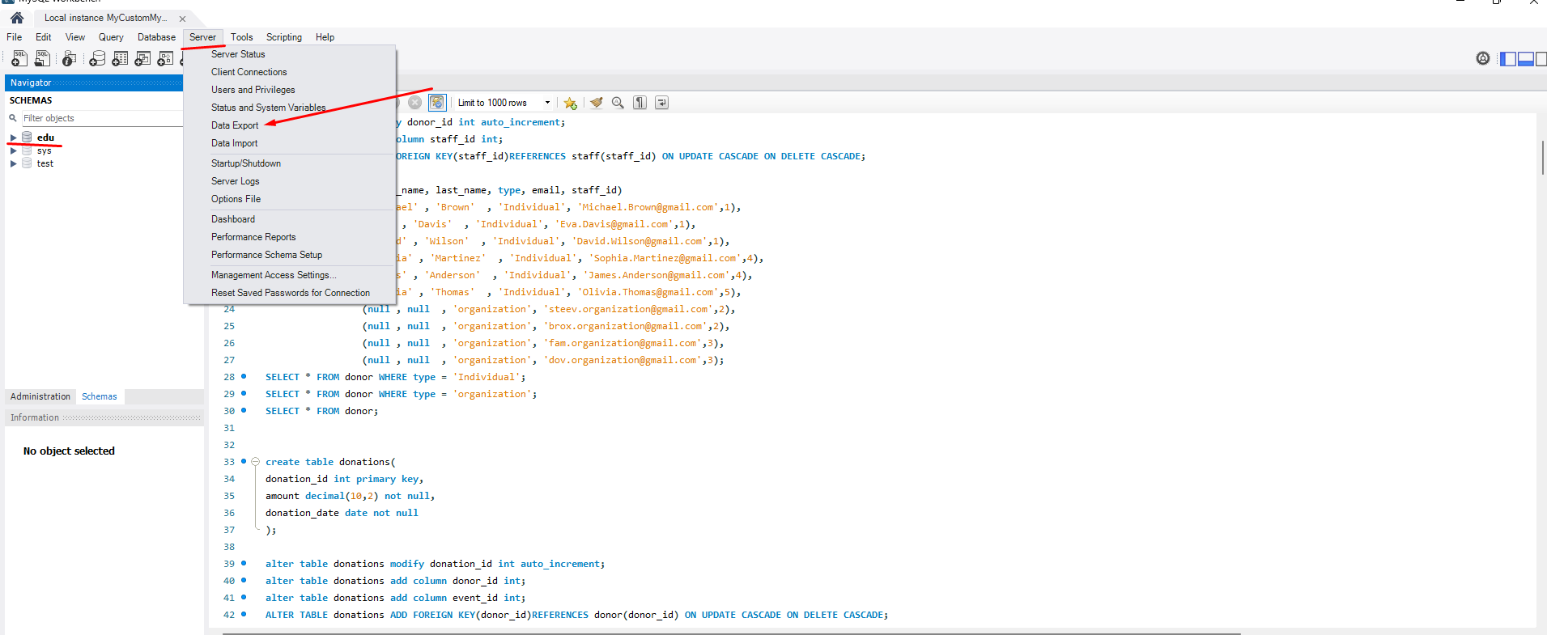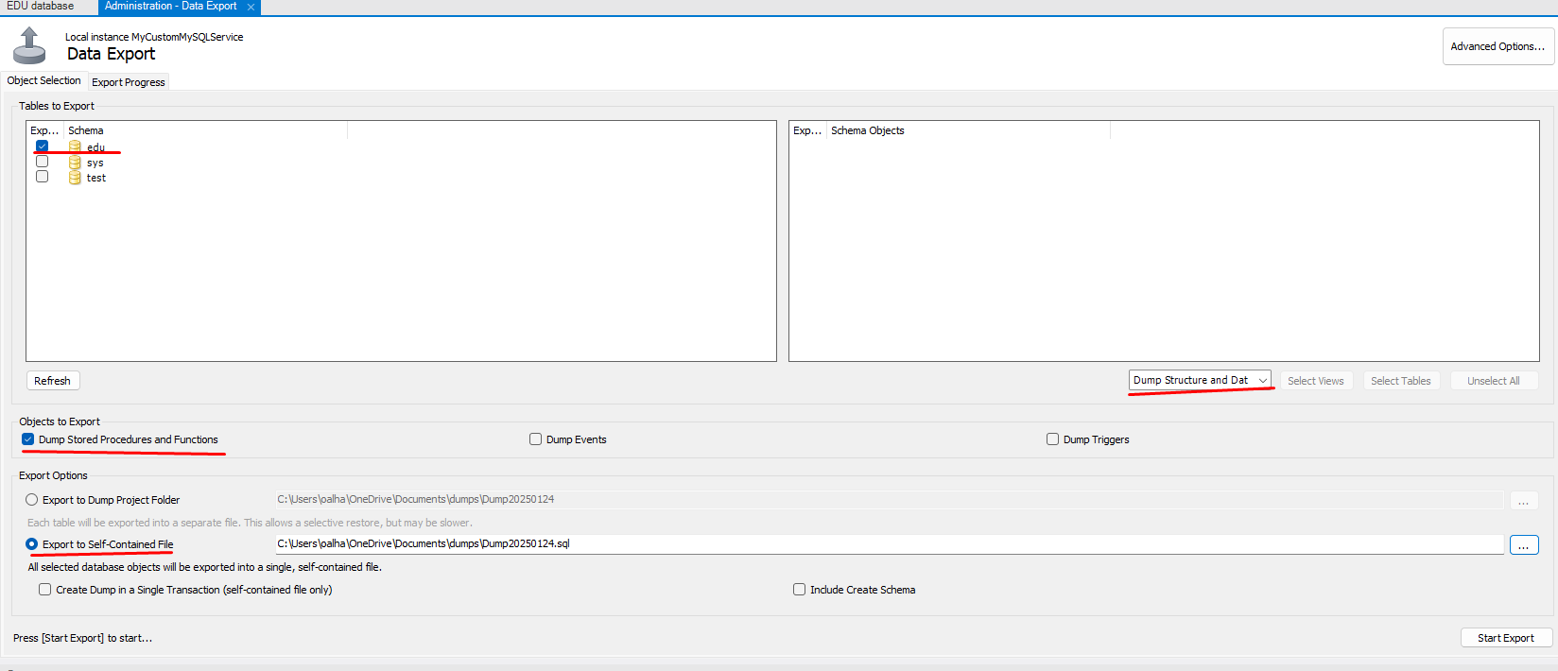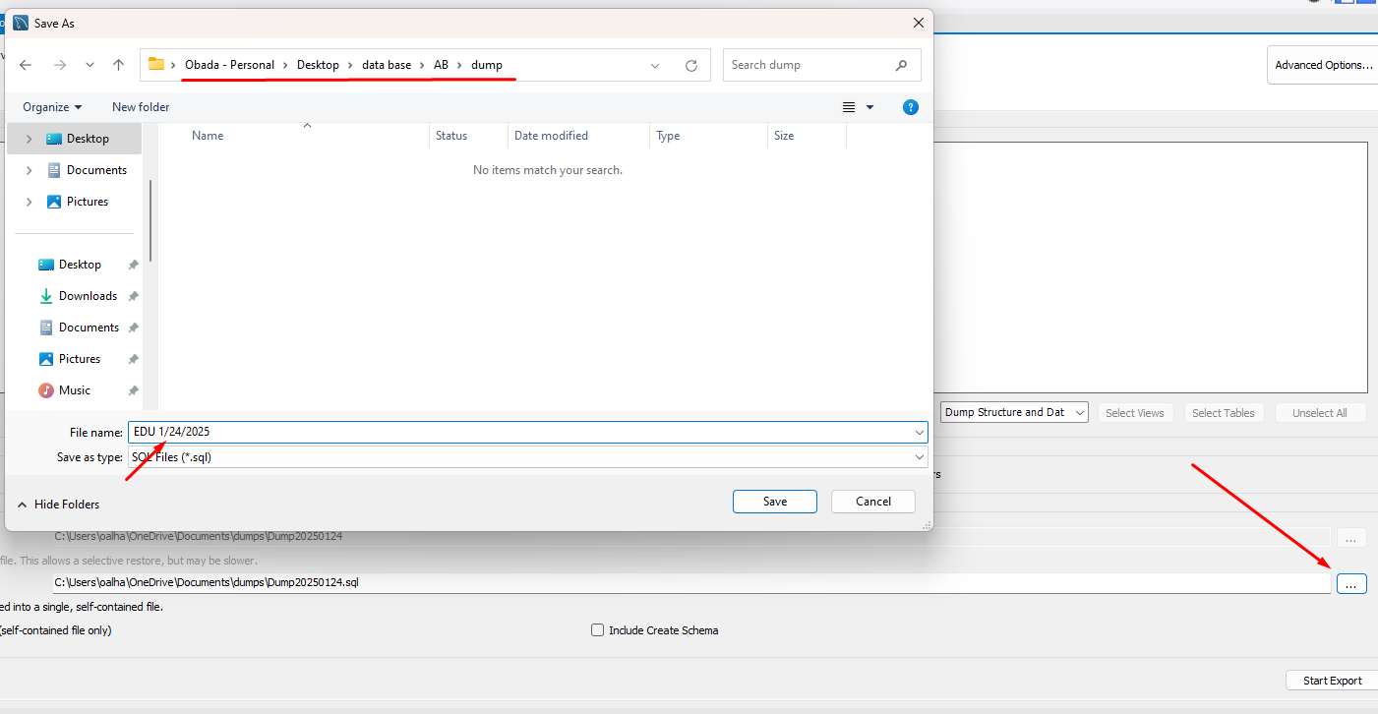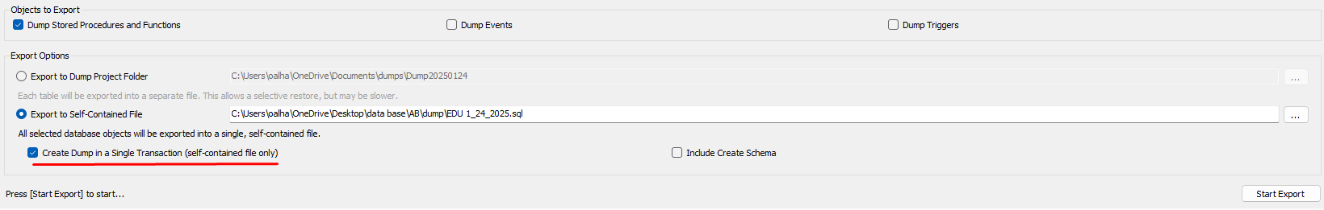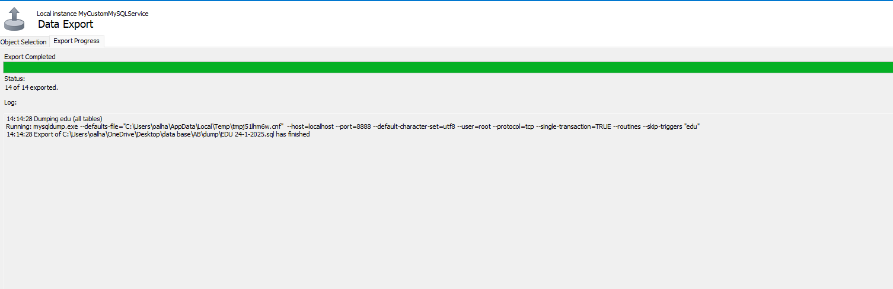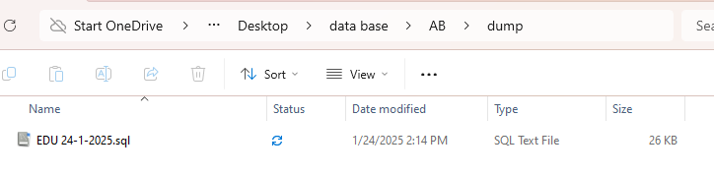

import:
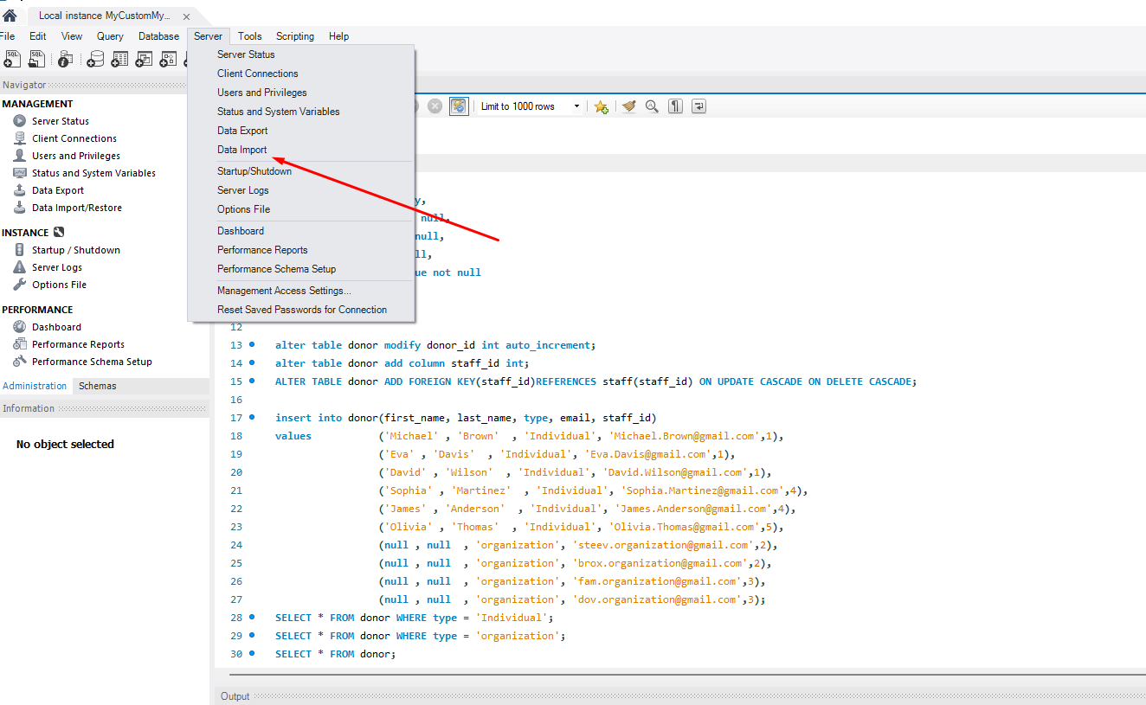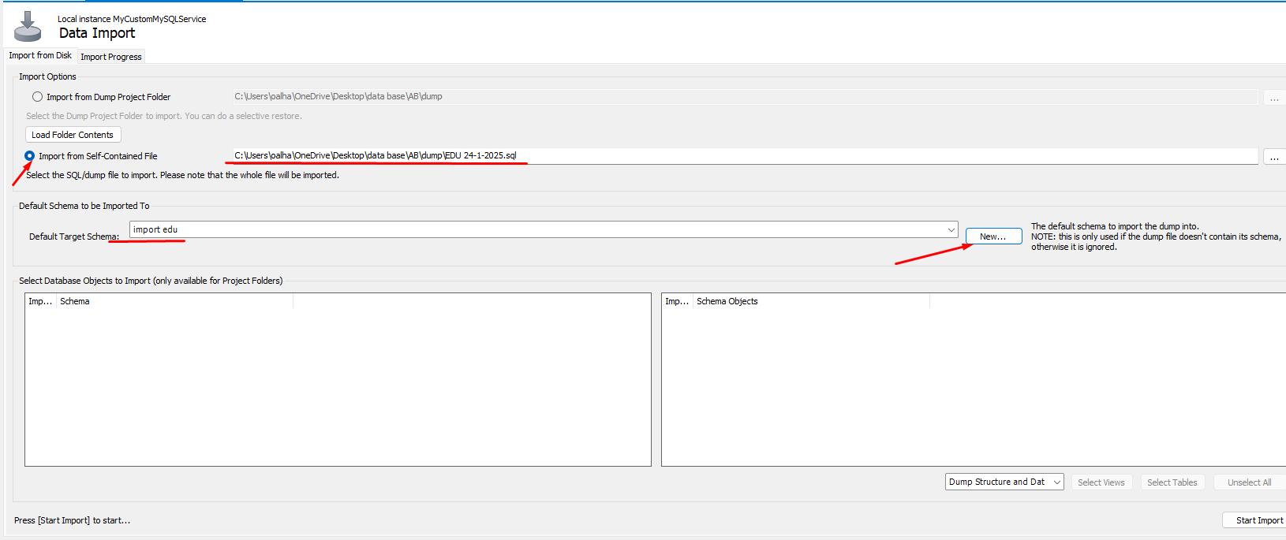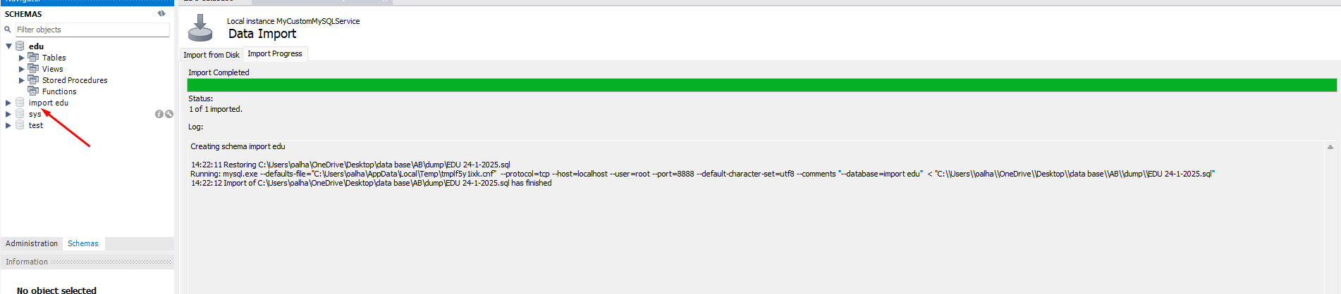

7.2 Database maintenance in general

First what is database maintenance, it is a set of procedures followed to ensure that a database operates properly.
The maintenance has a lot of benefits like:
- Keeping companies up to date: with the technology moving rapidly the organization try to keep up with it as if you are up to date you will have a sloid stand against others , if the organization fail to do that it will fall for the present standards, with regular database maintenance the organization data will be as up to date as possible and help it stay up.
- Promoting efficient database: the efficiency comes from getting rid of any extra unwanted data that may hinder the database performance, as it is important to ensure the database is at its peak performance.
- Simplifying data recovery: sometimes the data may be lost but with maintenance it will generate archival backups for important data to enhance data recovery.
- Protects against malicious threats: some times the system could face cyber threats without your knowledge that could escalate to a big problem if not delt with fast, when doing regular maintenance you reduce the chances of getting infected by it since you can remove it.
- Save time: you can save big time if you go to the process of automating the maintenance process and you can have the spare time doing other things to improve the system
Methods of Database Maintenance:
- Regular Backups: maintaining regular backups is essential to preventing data loss from unanticipated circumstances like system malfunctions or cyberattacks. To guarantee data availability and ease catastrophe recovery, both local and off-site backups are advised.
- Index Optimization: indexes improve data retrieval speed but can become fragmented over time. Regularly rebuilding or reorganizing indexes enhances query performance and overall database efficiency.
- Integrity Checks: by detecting and fixing data corruption problems, integrity checks help to guarantee the database's dependability. For this, SQL Server tools like DBCC CHECKDB are frequently utilized.
- Security Updates: Applying the latest security patches and updates protects the database from vulnerabilities and potential threats. Regularly reviewing user permissions and access controls also enhances security.
- Monitoring and Alerts: Implementing monitoring tools and setting up alerts for performance metrics, storage utilization, and unusual activities enable proactive management and quick resolution of potential issues.

8 Testing

8.1 Data Validation

Number | Type | Description | screenshot
1 | All cases of PK | I am testing on donor table with donor_id (Uniqueness) | 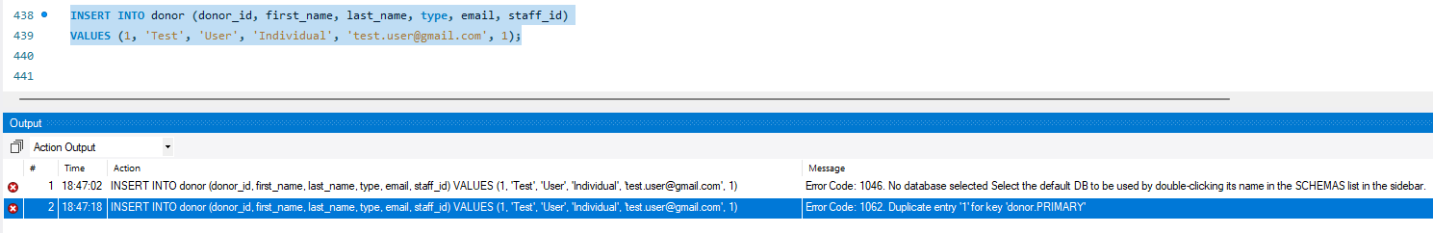
1 | All cases of PK | I am testing on donor table with donor_id (not null) | 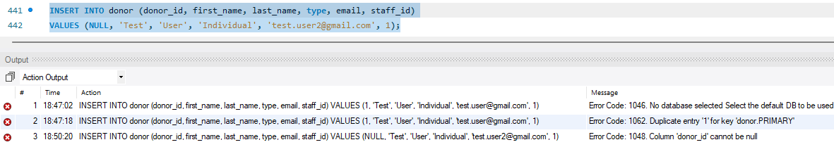
2 | All cases of FK | I am testing on donor table with staff_id(Non-existent PK) its pk from staff table | 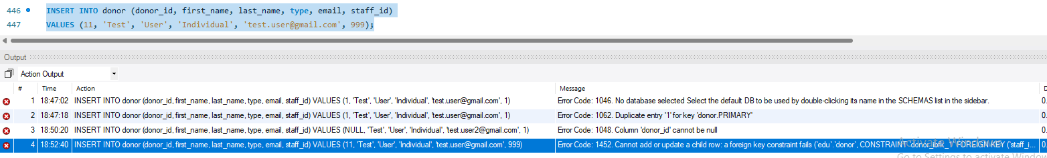
2 | All cases of FK | I am testing on donor table with staff_id(on delete cascade) its pk from staff table  the donor table after the delete | 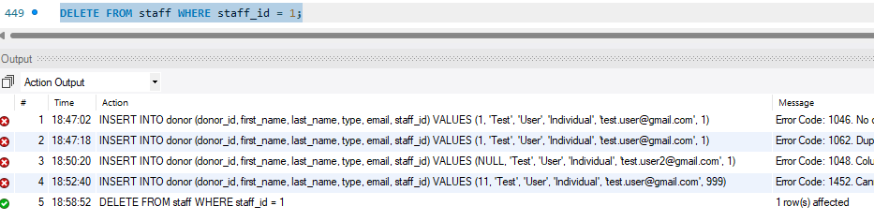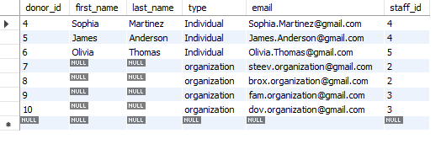
2 | All cases of FK | I am testing on donor table with staff_id(on delete restrict) its pk from staff table | 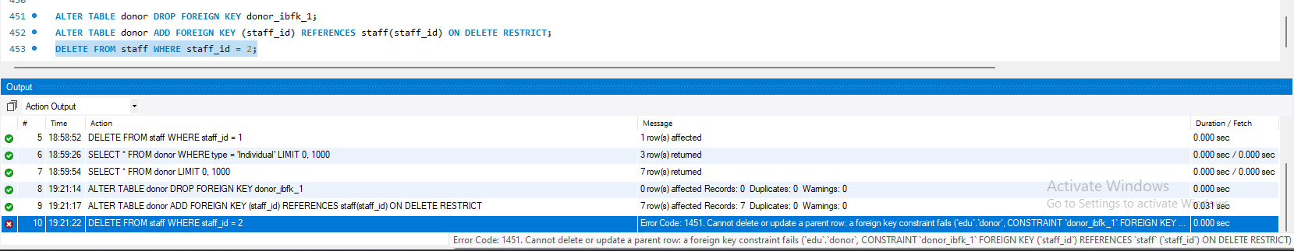
3 | Unique | I am testing on donor table with email (insert duplicate email) | 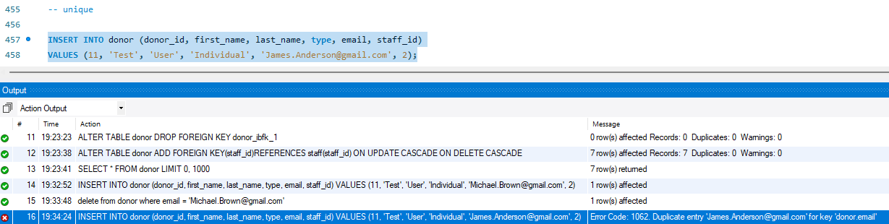
4 | Default | I am testing on staff table with role(insert value with no role specified) | 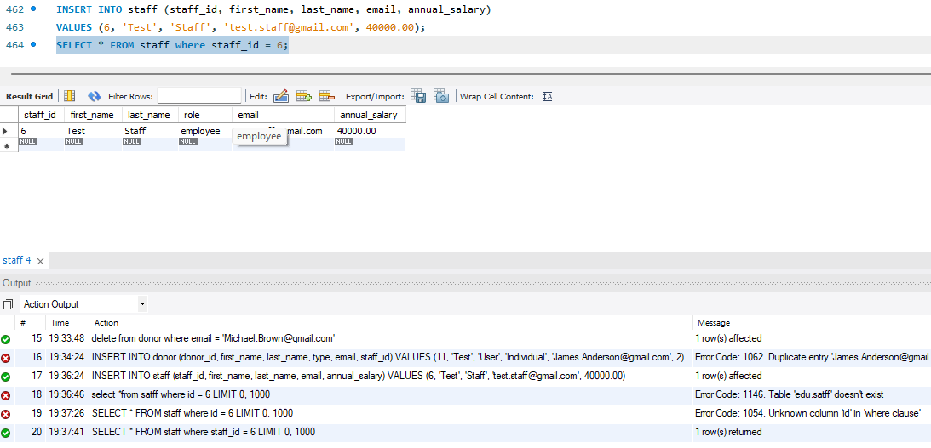
5 | Not null | I am testing on donor table with type(insert it null) | 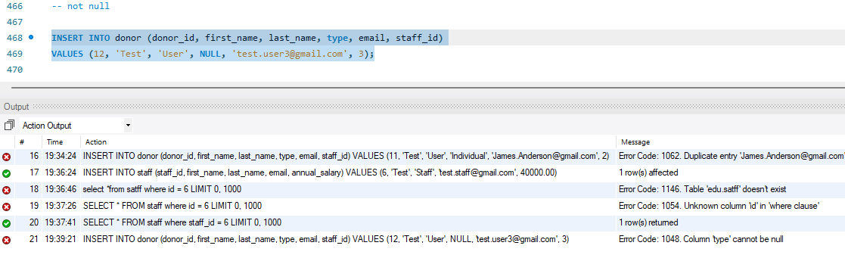

8.2 Output Validation
Number | Query Description | Screenshot (query + result) | Result validation
1 | This query aim to show the donors from the type organization only without the others | 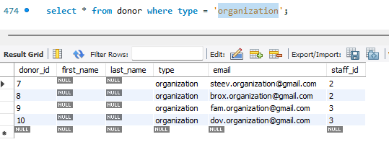 | 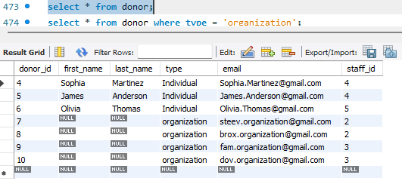  The result show the organization only without the individuals
2 | This query aim to add new staff member | 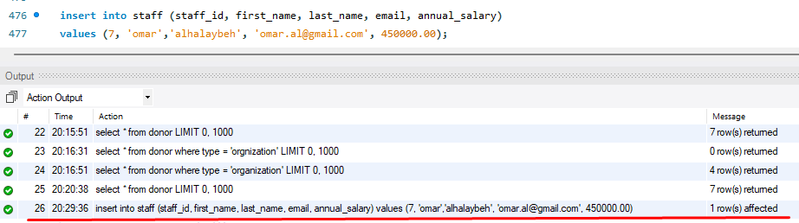 | 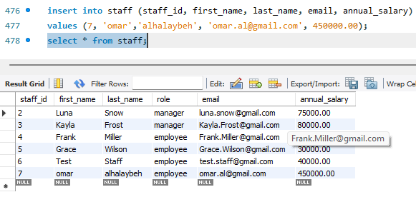
3 | This query aim to show the donor contribution and how many times he donated and the total of it  This query has 2 aggregate function (sum and count) | 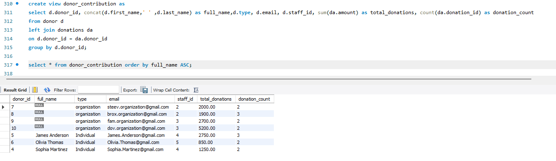 | 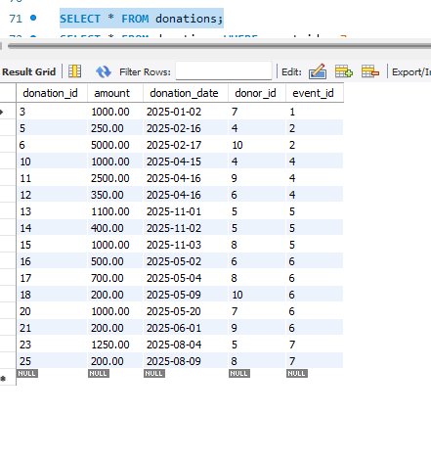  This is the donation table that show  donation info
4 | this query aim to use procedure called adddonor to add new clint | 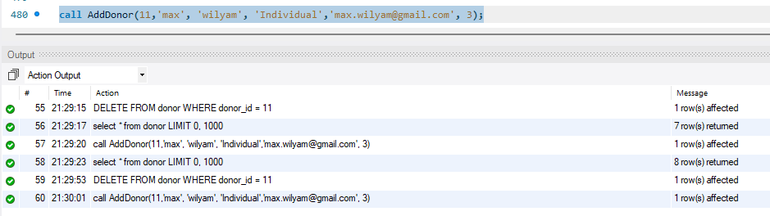 | 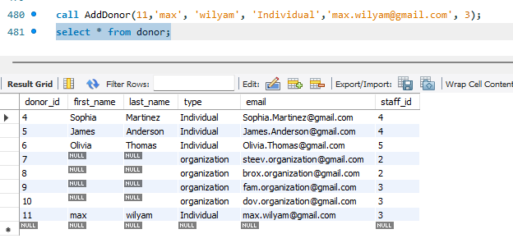

8.3 Security Validation
Number | Username | Description of privilege/no privilege | Screenshot (query + result)
1 | Staff | View(select) donor table to see the name of the donors | 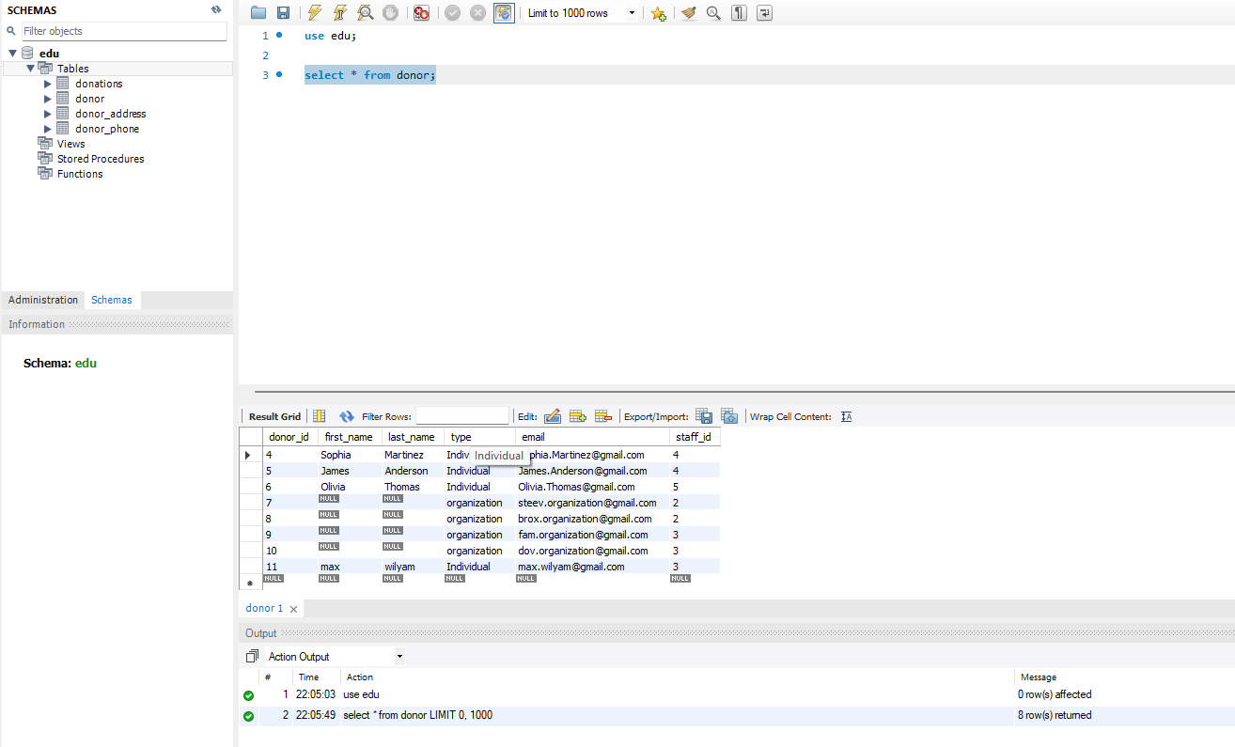
2 | Staff | Update donor phone table to change donor phone | 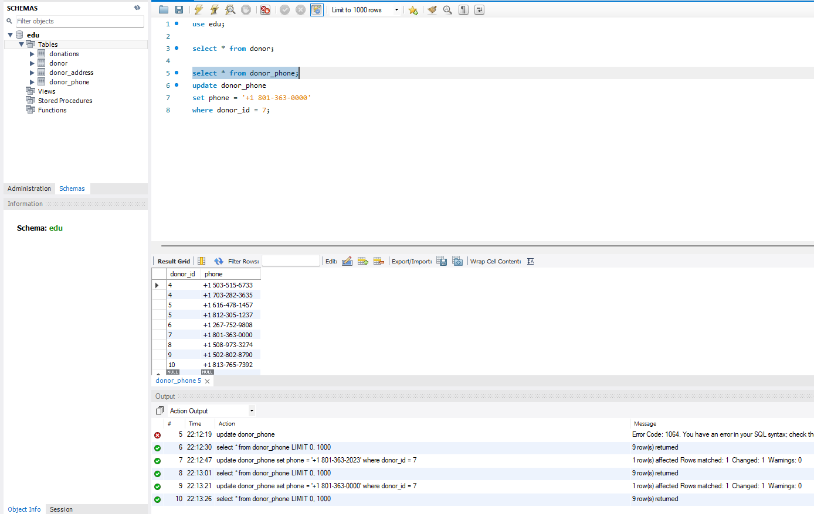
3 | Staff | Add new donor to the table | 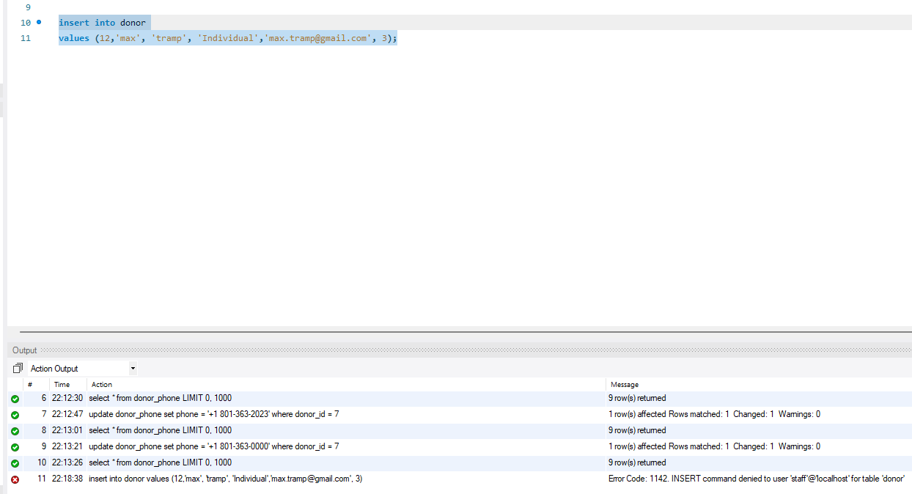
4 | Staff | View(select) a table that he do not have access to it | 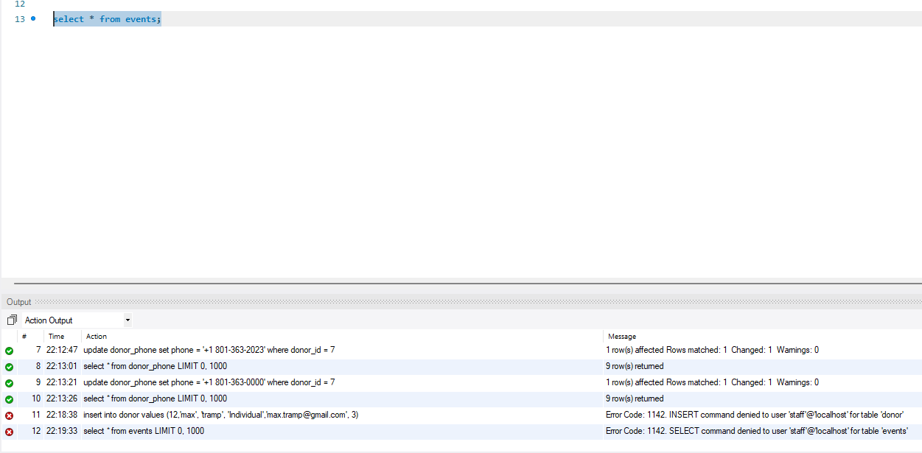

8.4 GUI Validation

Number | Description | screenshot
1 | 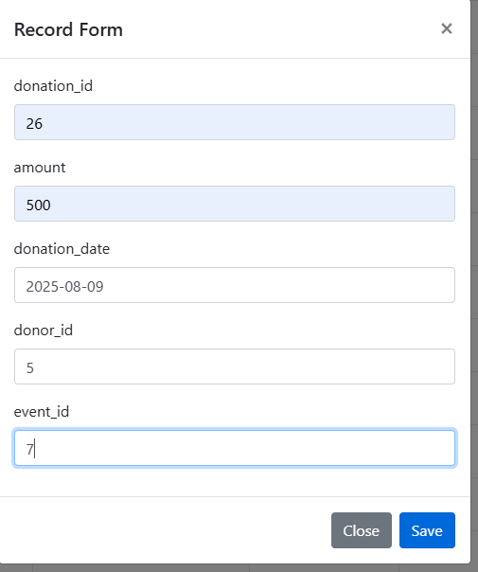  Add new donation | 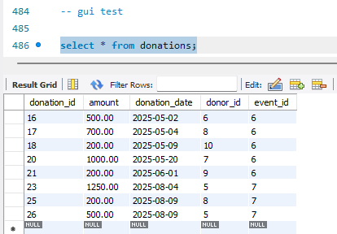
2 | 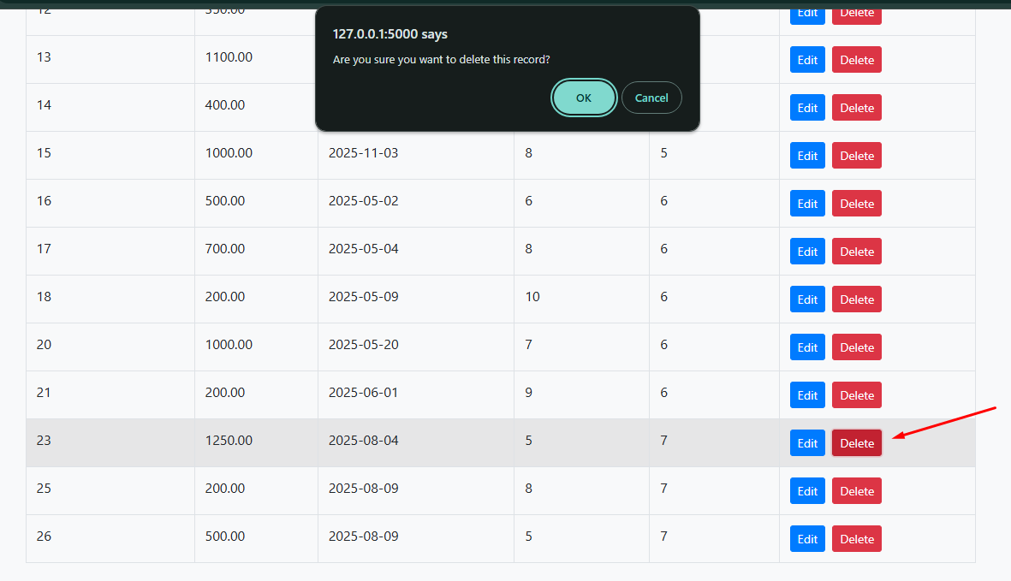  Delete record number 23 | 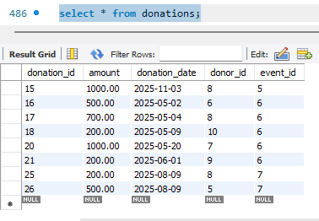
3 | 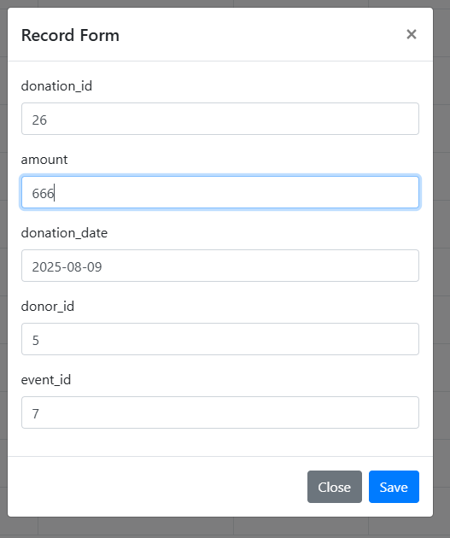  Update record number 26 change the amount | 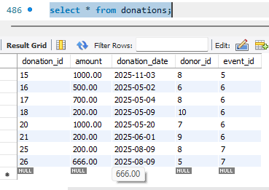
4 | 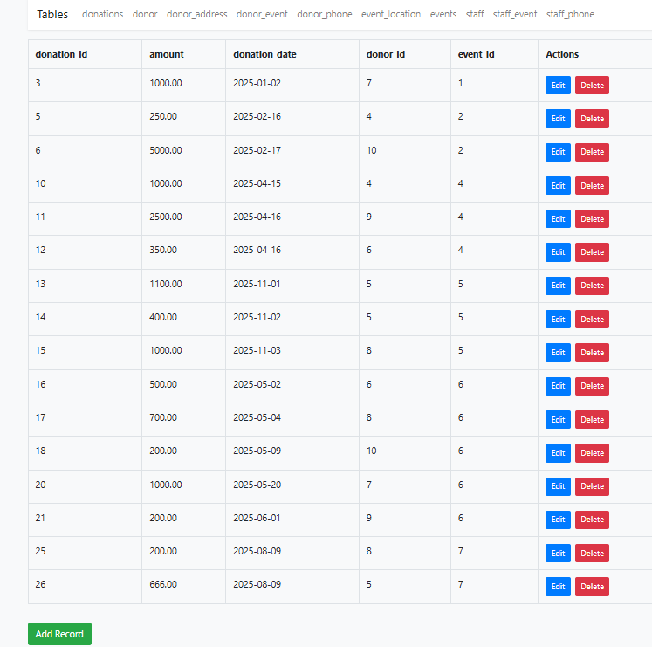  All the data is displayed | 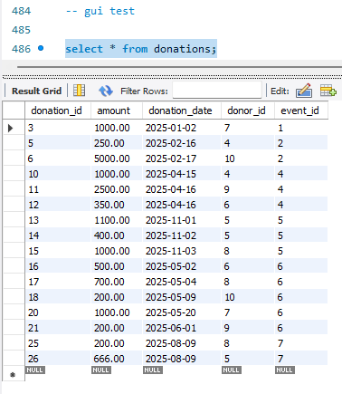

8.5 Assess whether meaningful data has been extracted
- For the multi-value attributes, I have on my database (donor_address, staff_phone, and donor_phone) they are multi-value because some donors could have more than one phone number and address and that work to the staff too they can have more than one number.
Sophia has 2 addresses
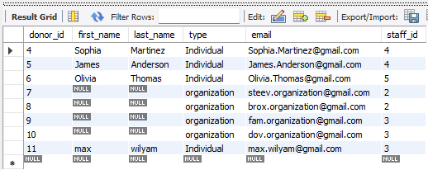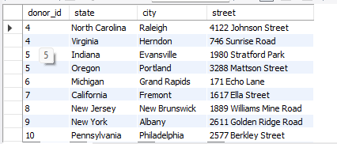

- 1:M Relations
  - One-to-Many relationships are demonstrated like this
  - Donor and Donations: Each donor (donor_id) can have multiple donations in the donations table.
this show that each donor can do multiple donations
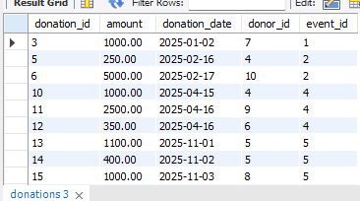
- Staff and Donors: Each staff member (staff_id) can manage multiple donors.
here is show that staff can manage more than one donor
- M:N Relations
  - Many-to-Many relationships are handled using linking tables
  - Donor and Events: The donor_event table connects donors and events
this show that a donor can go to more than one event and the event can host more than one user
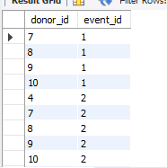
- Staff and Events: The staff_event table links staff members to events they contribute to or manage.
this show that staff can manage more than on event and event is managed by more than one satff
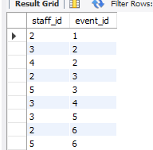
- Views
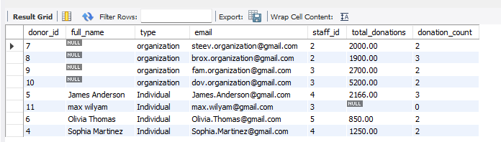
  - donor_contribution view: this view aim to summarize each donor's total contributions and donation count, the staff and admins can look at this view to count who donate more than the others to see who is the highest value donor.

  - event_donations view: this view aim to calculate the total donations for each event and provide event details, the staff and admins can determine which event was the most successful. 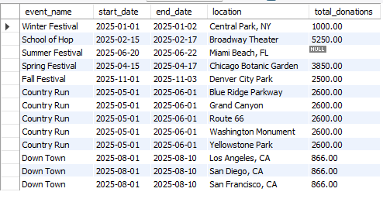

  - donor_contact_information view: this view aim to compile donor contact details, including addresses and phone numbers, this view will help staff and admins to keep in touch with the donors with the contact details offered in it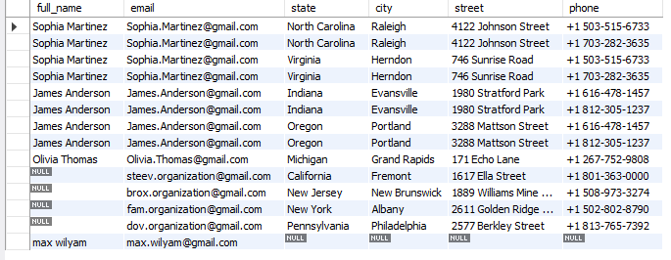

  - staff_contribution_report view: this view aim to analyze staff performance in terms of donors managed and donations facilitated, this view help the admin to see if the staff are doing good in there jobs.
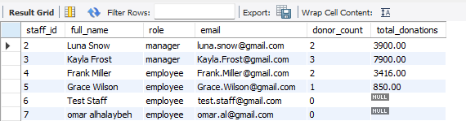

- procedueres
  - AddDonor: aim to add new donors in the database, it allows automated insertion of donor data with minimal errors.
  - UpdateDonorEmail: aim to update donor email, it maintains data consistency by ensuring emails are correct.
  - AddDonation: aim to add new donation record , it Streamlines the process of adding donations linked to donors and events.
  - AssignStaffToEvent: aim to link staff members to events, it Tracks staff participation and responsibilities for events.
Benefits for the users:
- Donor Engagement: With views like donor_contribution and donor_contact_information, fundraising teams can build meaningful relationships with donors by understanding their contributions and maintaining updated contact details.
- Event Success Analysis: The event_donations view provides critical insights into event performance, enabling organizers to prioritize high-impact events and optimize future planning.
- Staff Performance Management: The staff_contribution_report equips management with data to evaluate staff performance, reward key contributors, and improve team efficiency.
- Streamlined Operations: Automated procedures like AddDonor, AddDonation, and AssignStaffToEvent reduce manual errors and save time, allowing the organization to focus on its mission.

8.6 Assess the effectiveness of testing
Testing guarantees that the database satisfies user and system requirements and is secure and operational. While confirming the correctness of the data stored and retrieved, it assists in locating mistakes in relationships, constraints, and queries.
Testing Steps:
- Primary Key Validation: Ensured uniqueness and non-null constraints on the primary keys of all tables (e.g., donor_id, donation_id).
- Foreign Key Validation: Verified referential integrity through tests such as cascading updates and deletions. For example, deleting a staff_id ensured cascading deletions in related donor records.
- Constraints Testing: Checked constraints like NOT NULL, DEFAULT, and UNIQUE. For instance, inserting duplicate emails for donors demonstrated the UNIQUE constraint.
- Query Validation: Validated complex queries, views, and stored procedures to ensure meaningful data extraction.
- Security Validation: Verified user permissions, ensuring access levels (SELECT, UPDATE) were enforced as expected.
The importance of each step:
- PK and FK Validation: Maintains data integrity and ensures relationships between tables are implemented correctly.
- Constraint Testing: Prevents invalid or inconsistent data from entering the database.
- Query and View Validation: Ensures the accuracy and relevance of extracted data for users.
- Security Validation: Prevents unauthorized access and ensures that users have only the necessary privileges.
During testing, a number of small problems were found and fixed, including missing constraints and duplicate email entries. Additionally, the donor_event table verified the success of relationships such as M:N between Donor and Events.

9 Evaluation of database solution

9.1 Effectiveness of the database solution based on user and system requirement
The database system that was put into place was made to manage donor data, track donations, plan events, and streamline staff-donor communications in order to meet the EDU Youth Foundation's operational demands. The key objective was to provide a scalable and reliable solution that seamlessly combines user and system requirements while preserving data confidentiality and integrity.
The database fulfills its intended purpose by providing an efficient mechanism to store and retrieve data. It meets key user requirements such as enabling donors to register, manage their profiles, view their donation history, and participate in events. Similarly, the system empowers staff to manage donor records, track contributions, organize events, and communicate effectively. Admins are equipped with capabilities to oversee database operations and generate reports, ensuring they have a complete overview of the system’s functionality.
he database effectively fulfills user requirements by enabling donors to manage their profiles, view their donation history, and participate in events through a well-designed relational structure. This functionality is supported by the donor table and enhanced by views like donor_contribution, which provide insights into each donor’s contributions. Similarly, staff members can efficiently manage donors and events, thanks to the relationships established in the database, such as the one-to-many (1:M) relationship between Staff and Donor and the many-to-many (M:N) relationship between Staff and Events. This is further supported by views like staff_contribution_report, which offer a clear summary of staff performance and the donors they manage. Administrators benefit from comprehensive access to the system, allowing them to oversee database operations, generate detailed reports, and analyze performance using stored procedures like AddDonor and views like event_donations.
The database also effectively meets the defined system requirements by ensuring data integrity, usability, and scalability. Data integrity is maintained through the use of primary and foreign keys, along with constraints like NOT NULL and UNIQUE, which prevent invalid data entries. Referential integrity is upheld across all tables, ensuring consistency in relationships, such as those between donors, staff, and events. Usability is enhanced through the implementation of views and stored procedures, which simplify data access and manipulation for users with varying levels of technical expertise. For example, views like event_donations and procedures such as AddDonation allow for efficient querying and updating of critical data. Scalability is achieved through a normalized schema that reduces redundancy and ensures the database can accommodate growth in the number of donors, staff, events, and donations without compromising performance. These features collectively ensure that the database is robust, user-friendly, and prepared for future expansion.
Conclusion
By offering a safe, scalable, and well-structured system for managing donors, employees, events, and donations, the database solution successfully satisfies the user and system needs of the EDU Youth Foundation. It accomplishes its objectives of scalability, usability, and data integrity while permitting expansion and flexibility in the future. The database is adequate to meet the foundation's present and future operational requirements, however there is always space for improvement.

9.2 Suggested improvements
Although the EDU Youth Foundation's database solution is reliable and efficient, there are still several places where it might be improved for increased scalability and functionality. Refining the design by adding more entities to capture more detailed information is one possible enhancement. A "Volunteer" entity, for example, might be added to better track the roles and availability of non-staff members participating in events. This would increase operational efficiency and assist the organization in more effectively allocating resources during events.
Extending the attributes in already-existing entities could be another improvement. For instance, new attributes like budget or target_donations may be added to the Events table to enable more thorough financial analysis and event planning. In a similar vein, to increase donor involvement and facilitate communication, the Donor table may incorporate fields like preferred_contact_method or donation_frequency. The database would become more adaptable and user-focused with these additions.
From a security perspective, the system could benefit from more granular user roles and privileges. Currently, privileges are defined at a broad level for admin, staff, and donor roles. Introducing more specific roles, such as event coordinators or financial analysts, with tailored access levels, would enhance security and ensure users only access the data they need. Additionally, implementing logging mechanisms to track user activity within the system could further safeguard data and provide valuable insights into usage patterns.
Finally, incorporating dashboards or analytical tools into the database system may offer stakeholders useful information from a commercial standpoint. This would enable the EDU Youth Foundation to recognize patterns, evaluate the success of events, and efficiently maximize fundraising tactics. The database's usefulness, security, and capacity to accommodate the foundation's changing requirements would all be substantially improved by these recommended changes, even if they would involve more work and resources.

9.3 Evaluation based on improvements needed

The overall efficacy of the database solution provided by the EDU Youth Foundation would be greatly increased by putting the recommendations made in Section 9.2 into practice. Including new entities like "Volunteer" would enable the system to record more specific data, enhancing resource allocation and operational effectiveness during events. A more thorough understanding of event management would result from this improvement, guaranteeing that staff and non-staff participants are efficiently coordinated. Additionally, the organization would gain deeper financial insights by increasing the attributes of existing tables, such as adding budget and target_donations to the Events database. This would help with improved event planning and decision-making. The Donor table's fields like preferred_contact_method and donation_frequency would improve donor engagement and allow for customized communication tactics, which would strengthen ties with contributors in the long run.
The introduction of more granular user roles and privileges would strengthen the system’s security by ensuring that users only access the data necessary for their roles. This would minimize the risk of data breaches or unauthorized changes, providing stakeholders with greater confidence in the system's reliability. Implementing logging mechanisms would also improve accountability and allow administrators to monitor user activity, identifying potential misuse or inefficiencies in system operations.
However, these improvements are not without challenges. Adding new entities and attributes would require careful schema redesign and extensive testing to ensure compatibility with the existing structure. This could increase development time and resource requirements, especially for tasks like updating stored procedures, views, and existing queries to accommodate the changes. Similarly, implementing granular roles and logging mechanisms might involve additional complexity in configuring access permissions and developing monitoring tools.
despite these difficulties, the possible advantages greatly exceed the disadvantages. These enhancements would guarantee that the database stays useful as the foundation expands and changes by making it more thorough, safe, and flexible. Even though they would take more work and money, the improvements would make the database solution more future-proof and better able to fulfill the strategic and operational objectives of the EDU Youth Foundation.

10 User Documentation

10.1 System Overview
The database system of the EDU Youth Foundation is a consolidated solution created to increase the organization's data management, efficiency, and operational efficiency. In order for the foundation to efficiently track contributions, plan events, and keep in close contact with its stakeholders, its main goal is to manage data pertaining to contributors, donations, employees, and events.
The system is user-friendly and designed to cater to different roles within the foundation, including donors, staff, and administrators. Donors can manage their profiles, view their donation history, and participate in events. Staff members are equipped with tools to manage donor records, track donations, plan and oversee events, and communicate effectively with donors. Administrators have access to comprehensive reports and data insights, enabling them to monitor the organization's overall performance and ensure smooth operations.

10.2 Using the system
First for all users you should add the host ip then the port number which is 8888 in this case and the database name
For donor (normal user)
- Add the user name here is donor and add the password which is donor
- After that a page with the allowed tables to the user will show up
- Select the tables u want to check the information in then click next
- Then you can check the tables but you can’t alter anything since you are only
privileged to see them only
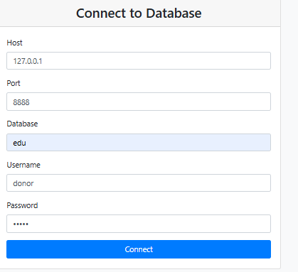 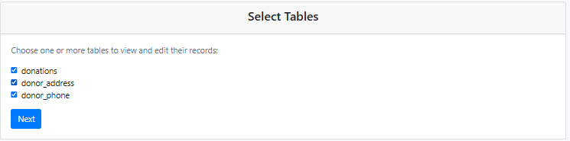 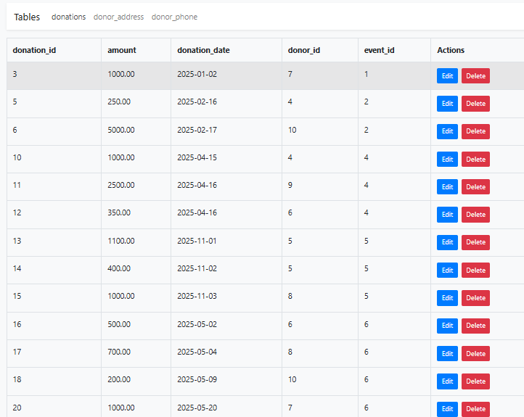
For staff
- You login with the staff username and password (staff)
- After that a page with the allowed tables to the user will show up
- Select the tables u want to check the information and update in then click next
- Then update the wanted user if needed
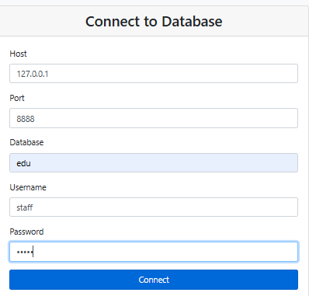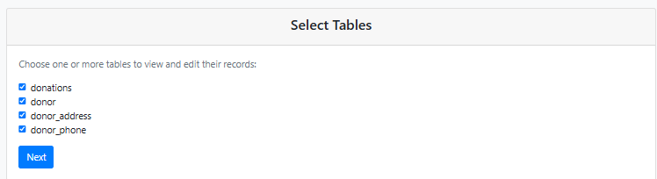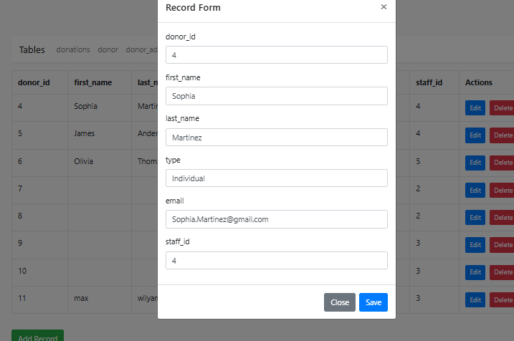

For admins
- You login with the admin username and password (admin)
- After that a page with the allowed tables to the user will show up
- Then you can do whaterve needed to be done since the admin has privleg to every thing
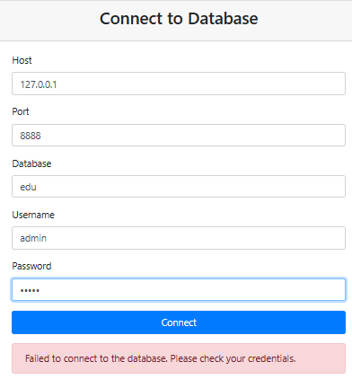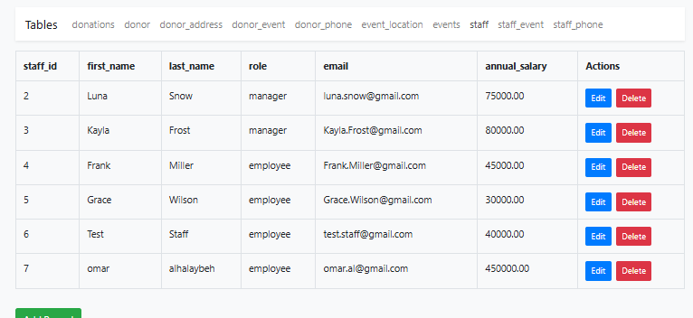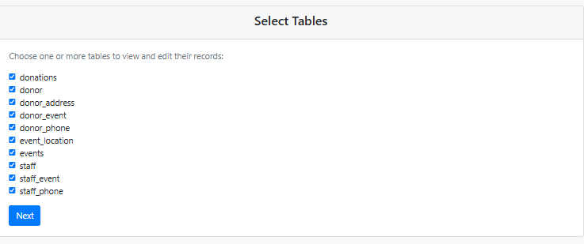
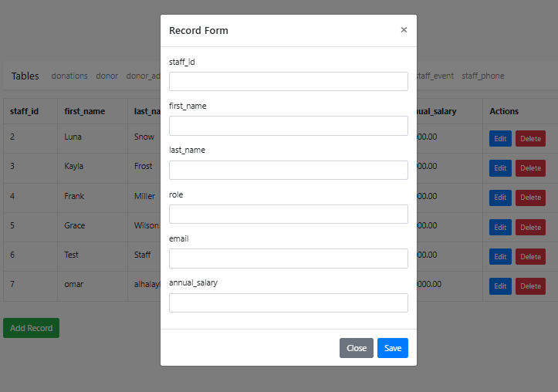

10.3 Frequently asked questions
Q1: What should I do if the database shows an error message when saving a donation?
A: Ensure that all required fields, such as the donation amount, date, donor ID, and event ID, are filled correctly. Double-check that the donor and event exist in the system. If the error persists, contact technical support.
Q2: How can I add a new event to the database?
A: To add a new event, staff members must navigate to the "Events" page and click the "Add Event" button. Fill in the required details, such as the event name, date, location, and budget, then save the changes.
Q3: Why am I unable to update donor information?
A: Only staff members with the appropriate privileges can update donor information. Ensure you are logged in with a staff account and have the necessary access rights. If the issue persists, contact the administrator.
Q4: Can a donor have multiple phone numbers or addresses?
A: Yes, the database is designed to handle multi-valued attributes for donors. You can add multiple phone numbers and addresses for a single donor in the donor_phone and donor_address tables.
Q5: How can I back up the database?
A: Administrators can back up the database using the export function in the database management tool. Go to the "Backup & Recovery" section, select the database, and follow the on-screen instructions to export the data to a secure location.

10.4 Contact information
Technical Support Contact Information

Email: support@eduyouthfoundation.org
Phone: +962 790944857
Operating Hours: Sunday to Thursday, 9:00 AM to 5:00 PM
Online Resources
- User Documentation Portal: www.eduyouthsupport.org/docs
- Community Forum: forum.eduyouthsupport.org – A place for users to ask questions, share experiences, and get help from the community.

Reference
Cohesity. (n.d.). What is Backup and Recovery? [online] Available at: https://www.cohesity.com/glossary/backup-and-recovery/.
‌Odogwu, C. (2022). What Is Database Maintenance and Why Is It Important? [online] MUO. Available at: https://www.makeuseof.com/what-is-database-maintenance/.
‌Seis, D. (2023). Essential Database Maintenance Tasks Every DBA Should Know. [online] SQL Server Consulting - Straight Path Solutions. Available at: https://straightpathsql.com/archives/2023/08/essential-database-maintenance-tasks-every-dba-should-know/?utm_source=chatgpt.com.
‌

